5m Asta

1- 3

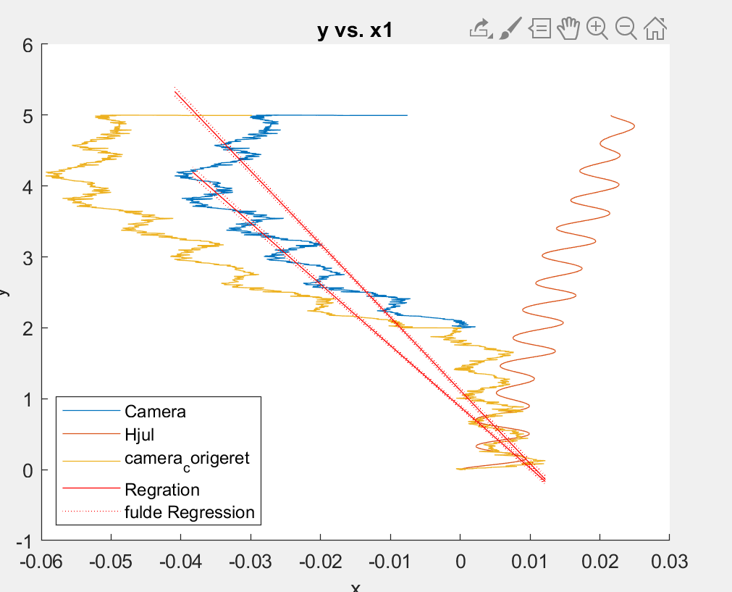 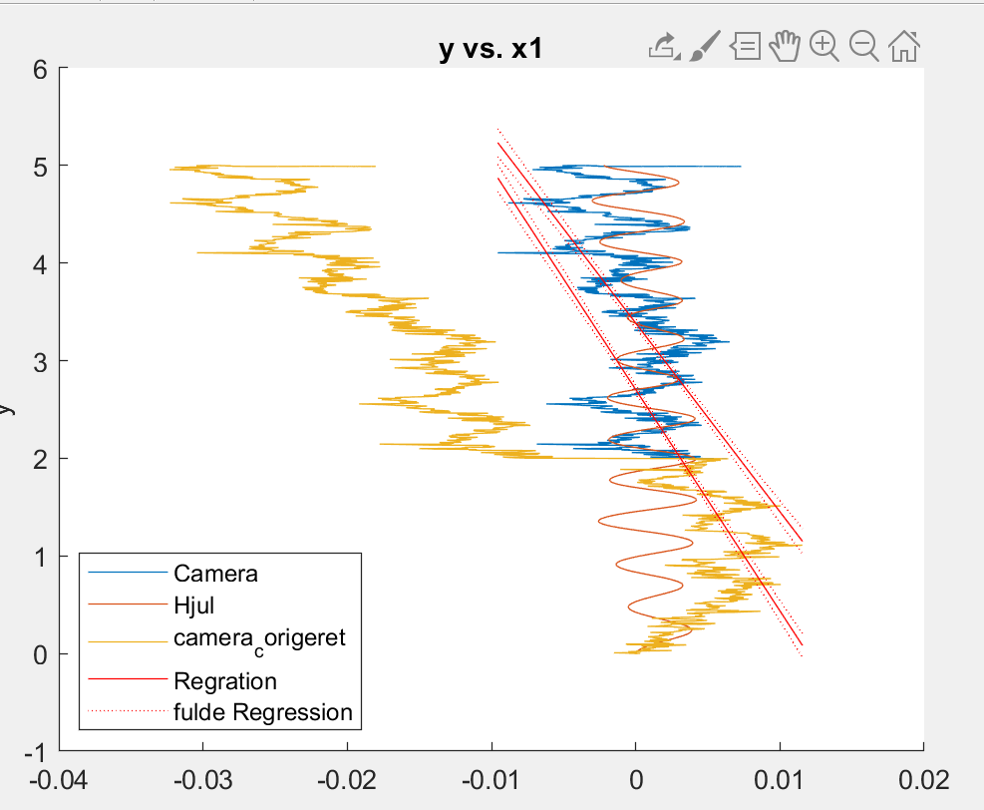 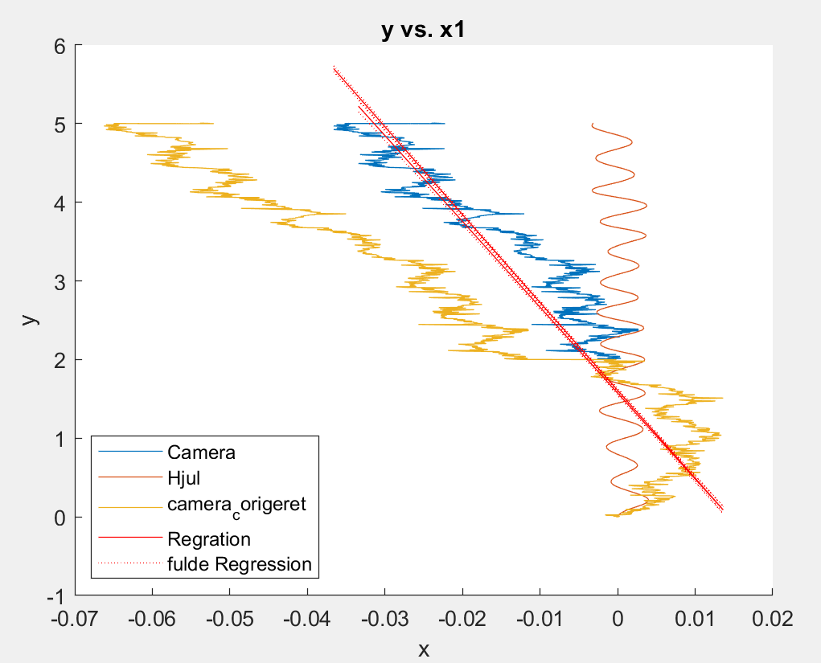

4 – 6

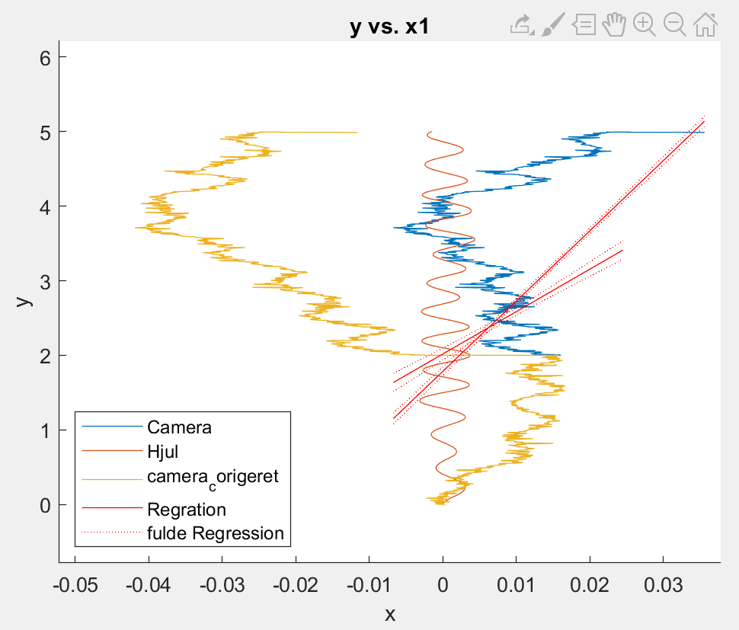 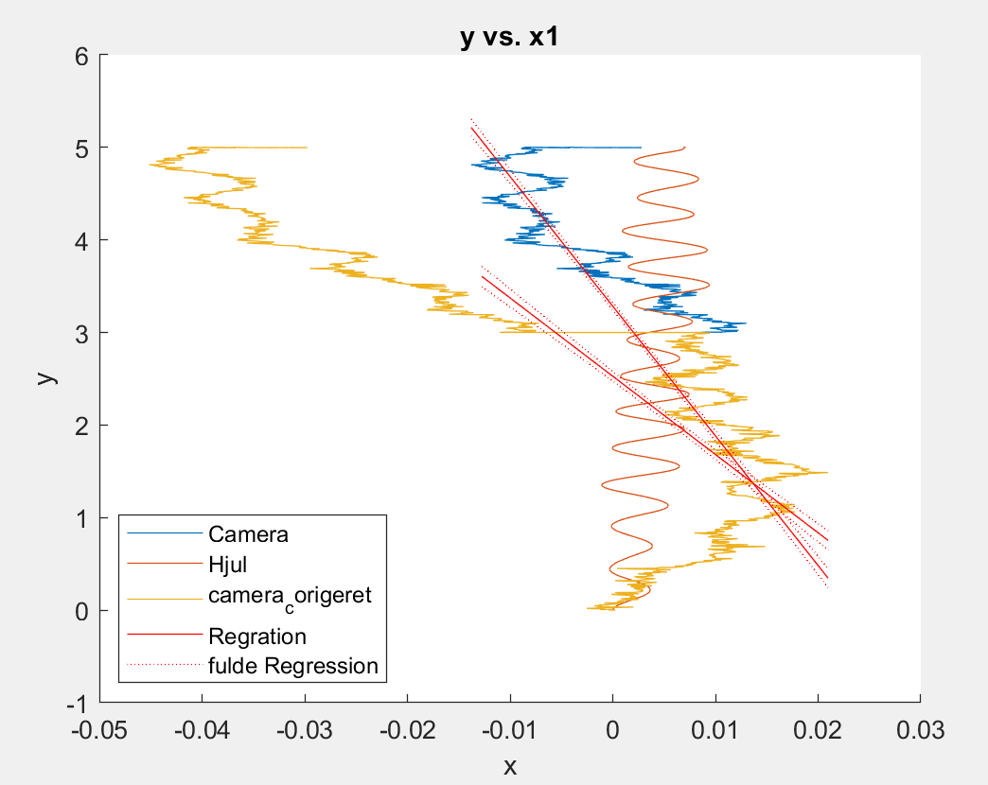 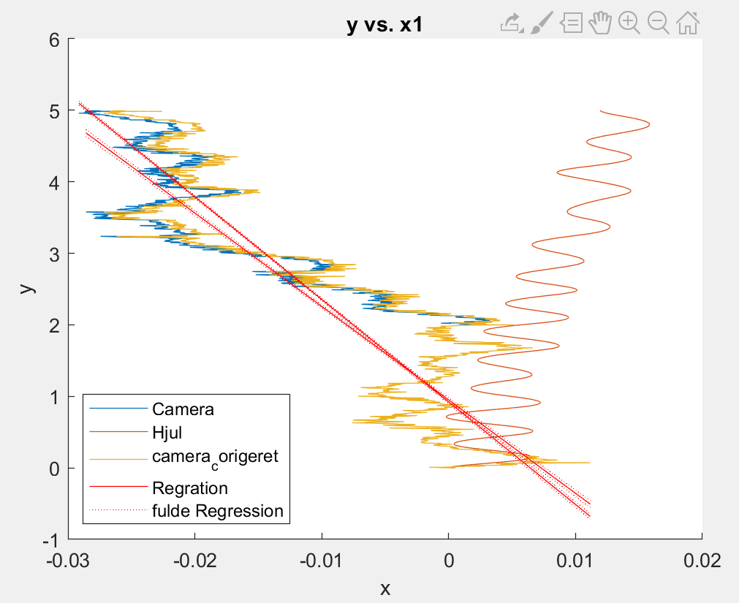

7-9

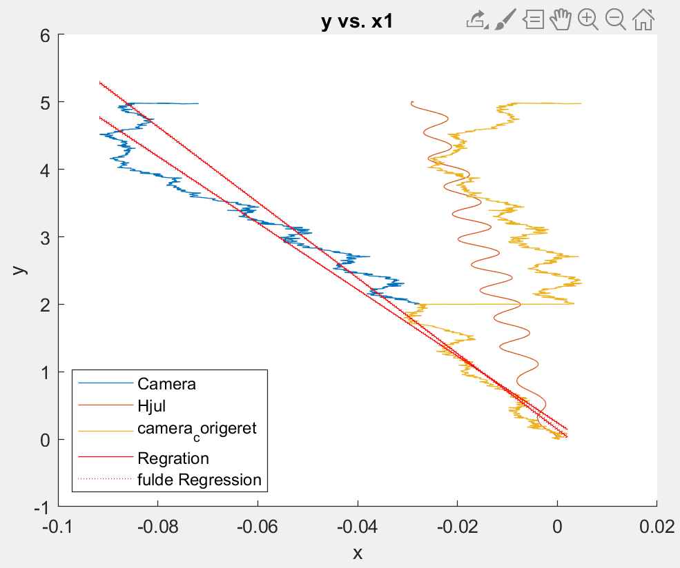 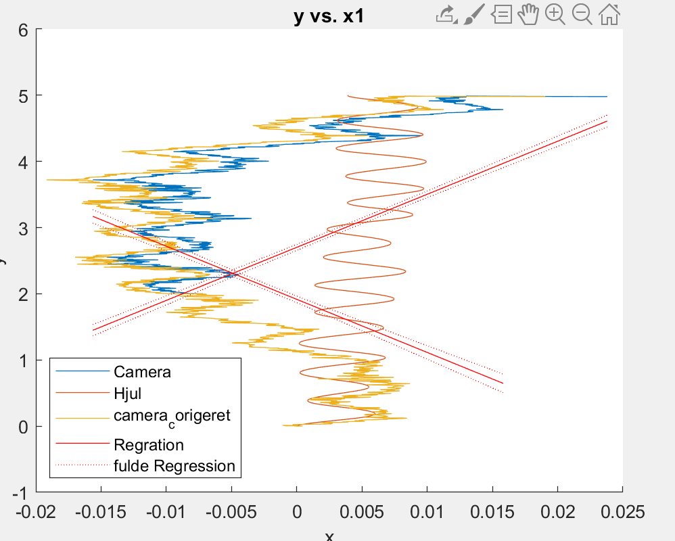 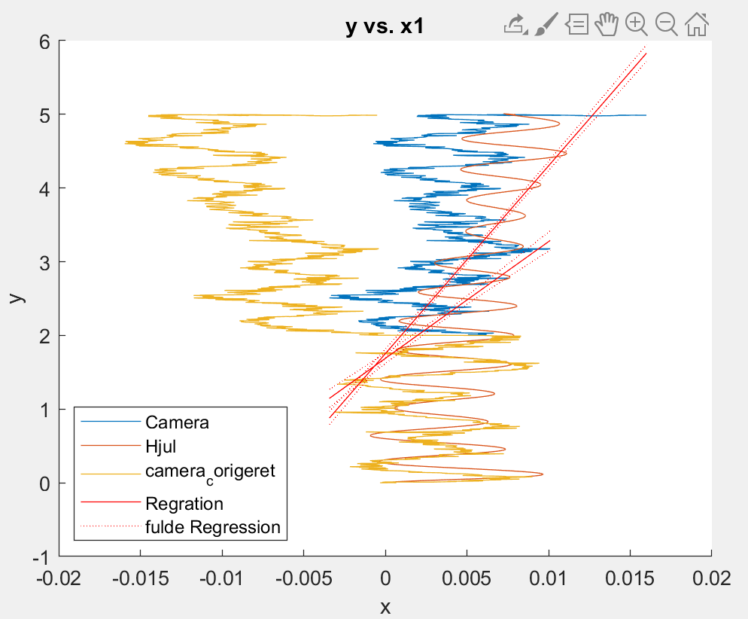

10

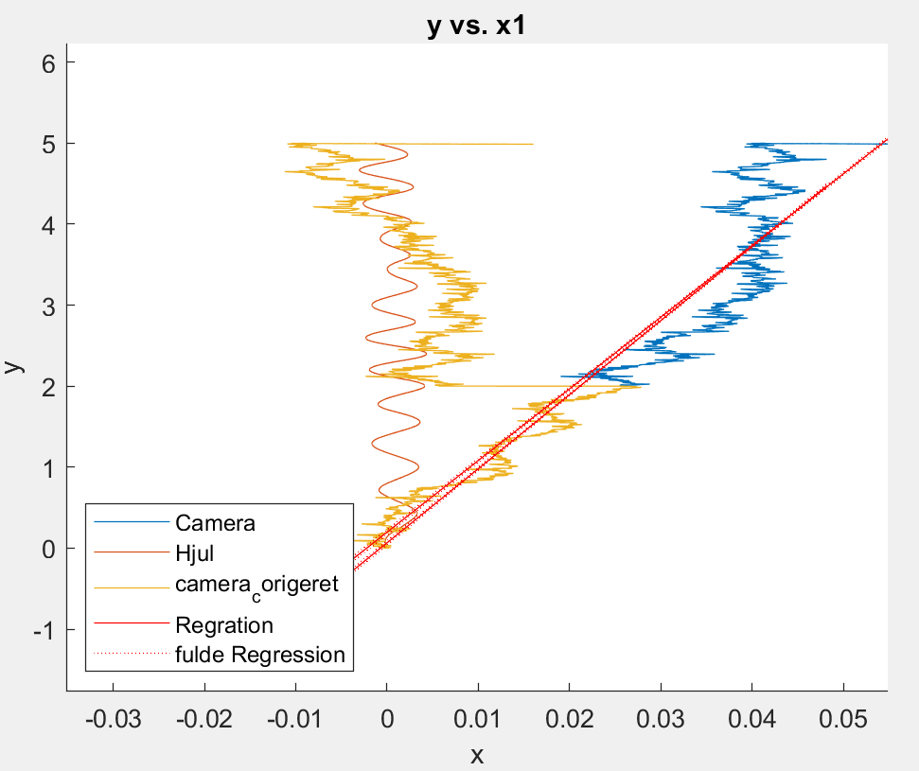

**Actual Deviation From 0**

Tur 1, 5m , 11 cm skewed (left)

Tu 2, 5m, 0cm

Tur 3, 5m, 0cm

Tur 4, 5m, 0cm

Tur 5, 5m, 0cm

Tur 6, 5m, 0cm

Tur 7, 5m, 2cm left

Tur 8, 5m, 3cm left

Tur 9, 5m, 0cm

Tur 10, 5m, 2cm left

10m ASTA

1-3

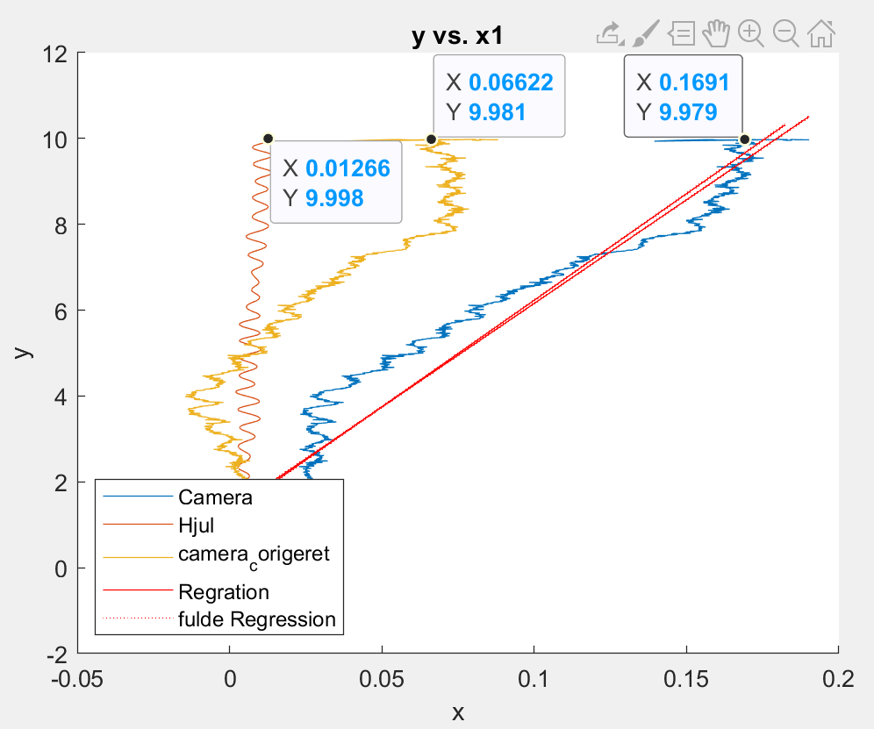 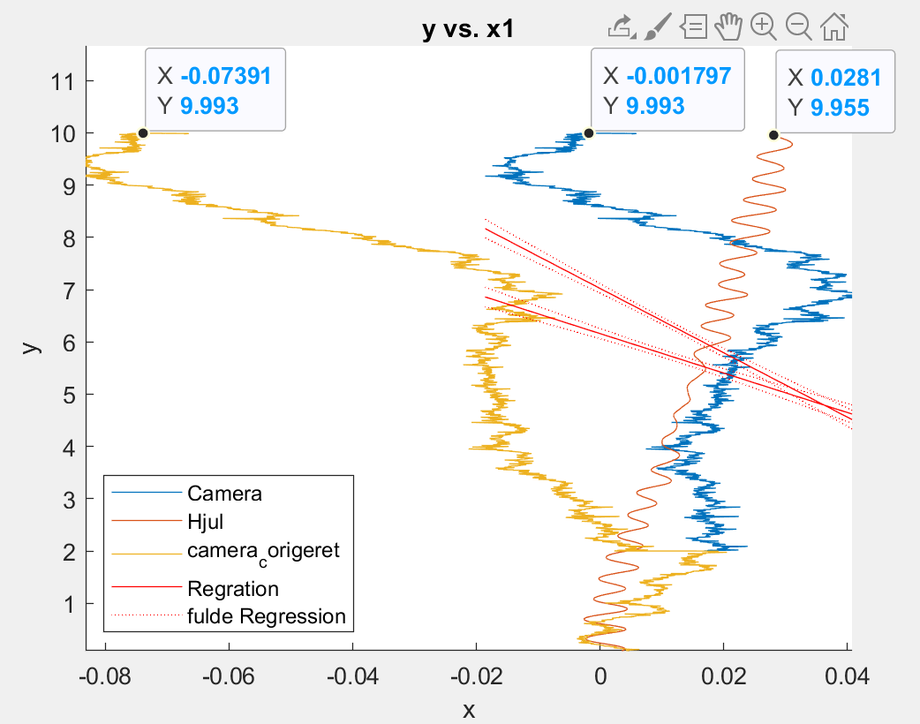 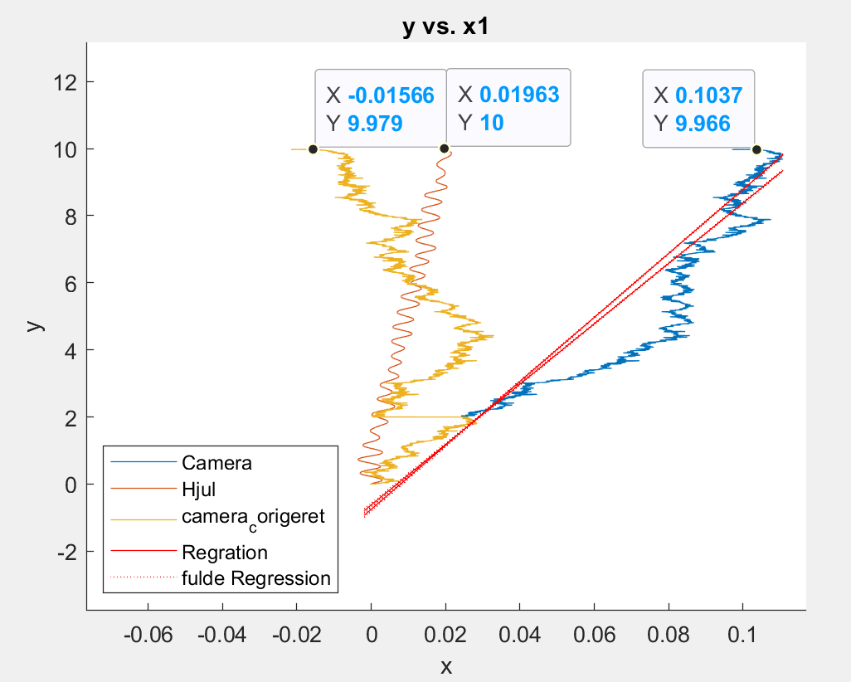

4-6

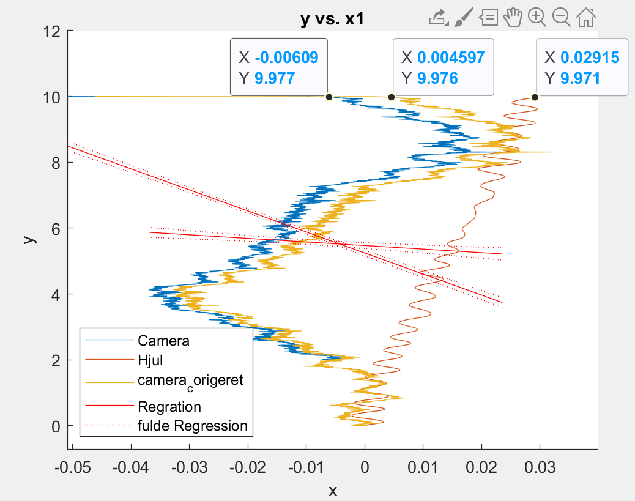 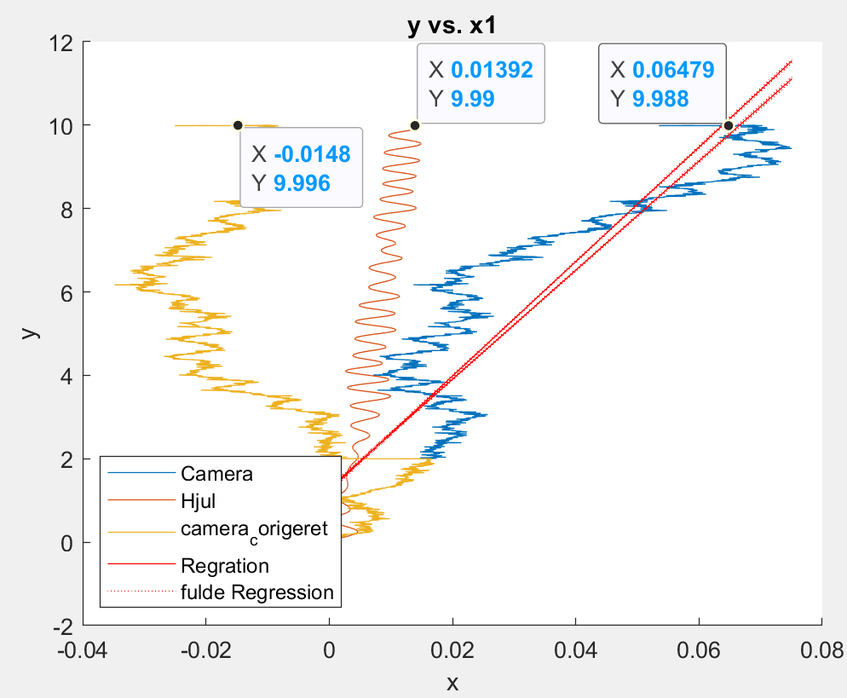 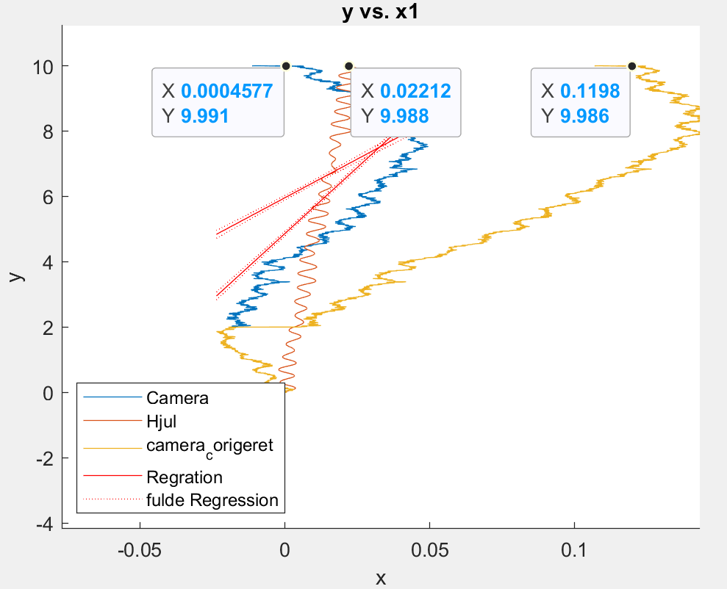

7-9

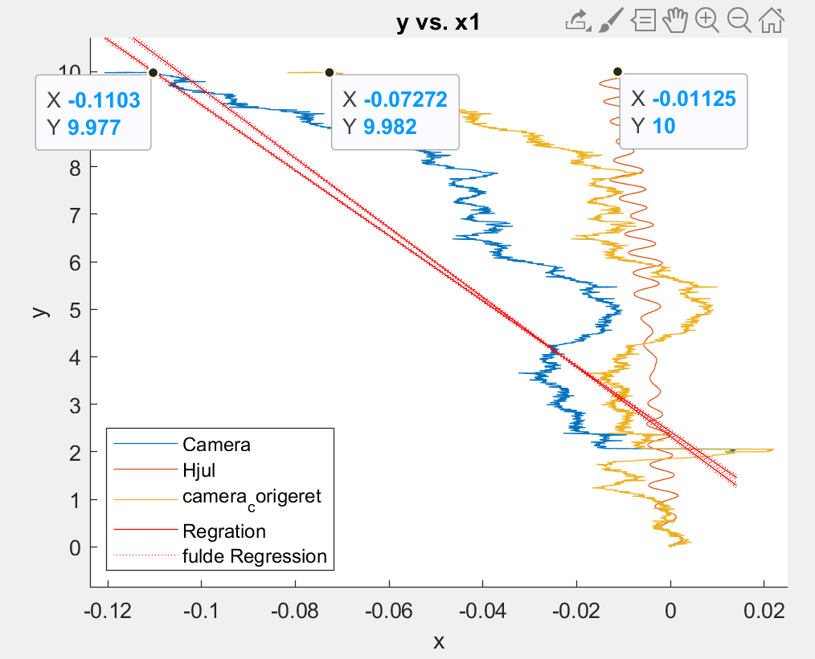 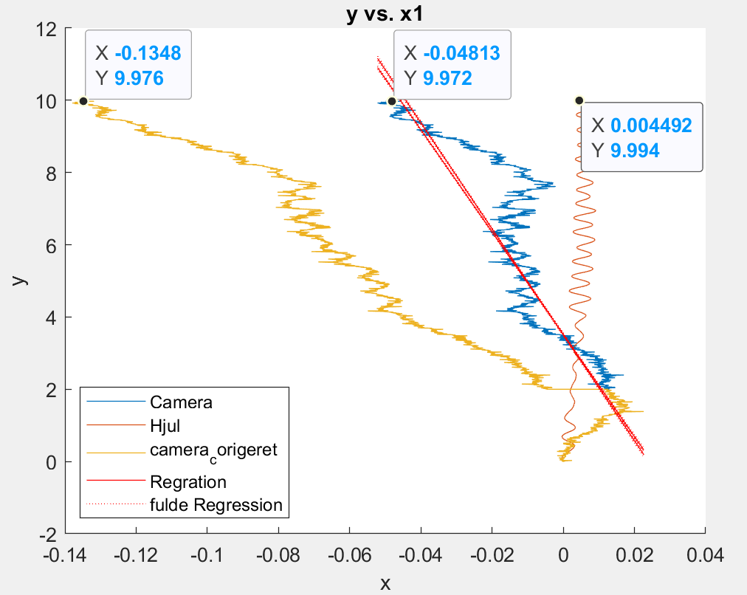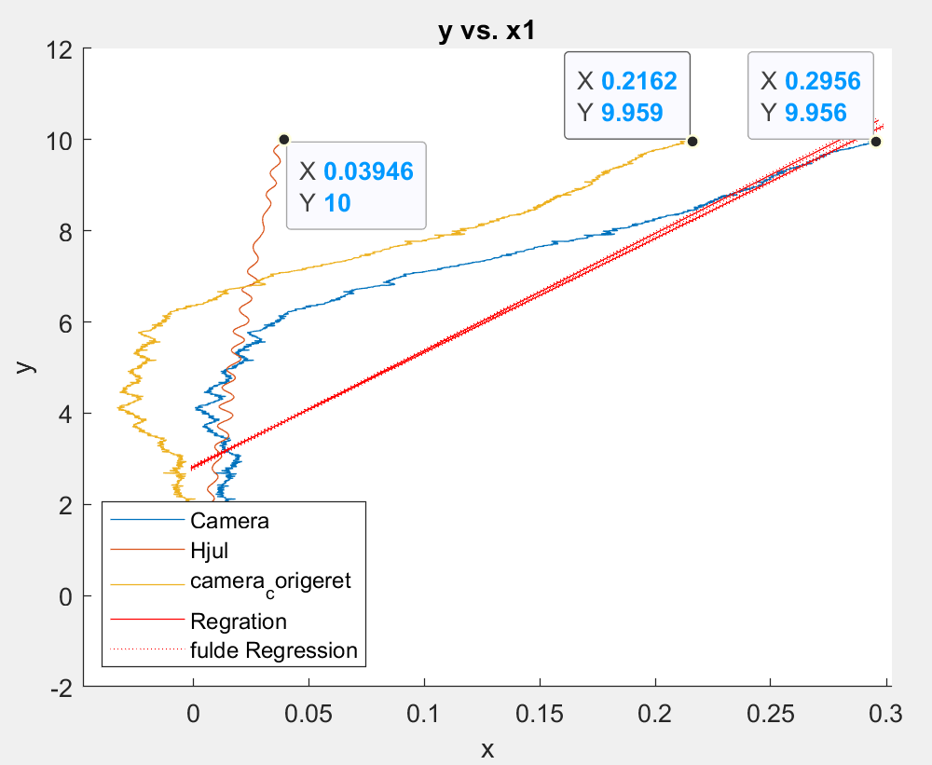

10

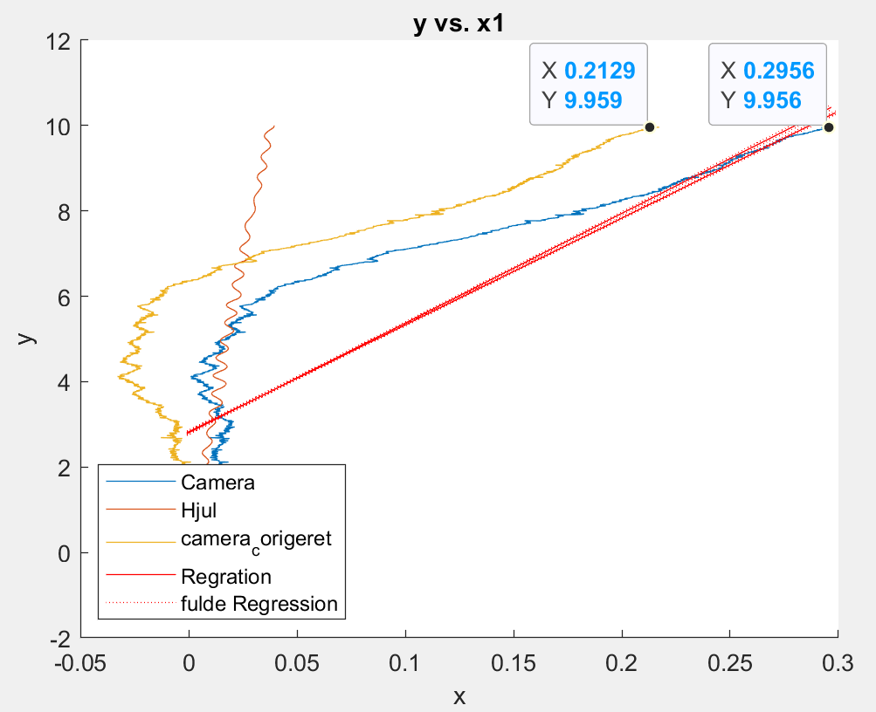

**Actual Deviation From 0**

10 m – Stopped at 9.985m

1, 9.985m, 0cm

2, 9.985m , 15cm left

3, 9.985m, 12cm left

4, 9.985m, 10cm right

5, 9.985m, 5cm right

6, 9.985m, 0cm

7, 9.985m, 1cm left

8, 9.985m, 16cm left

9, 9.985m, 17cm left

10, 9.985m, 30cm left

15m ASTA

1-3

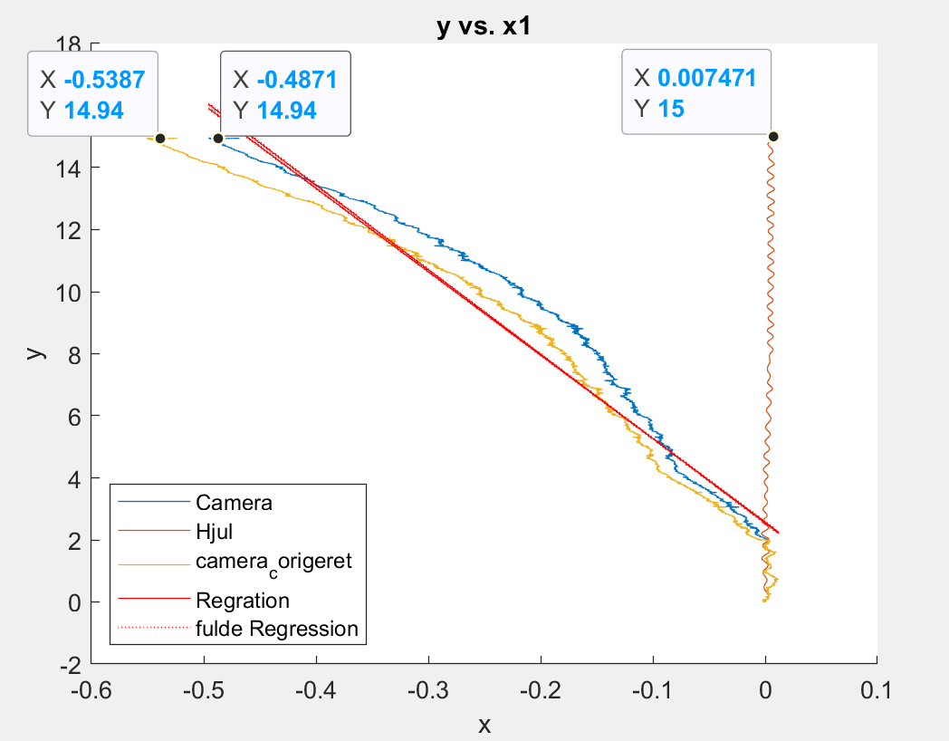 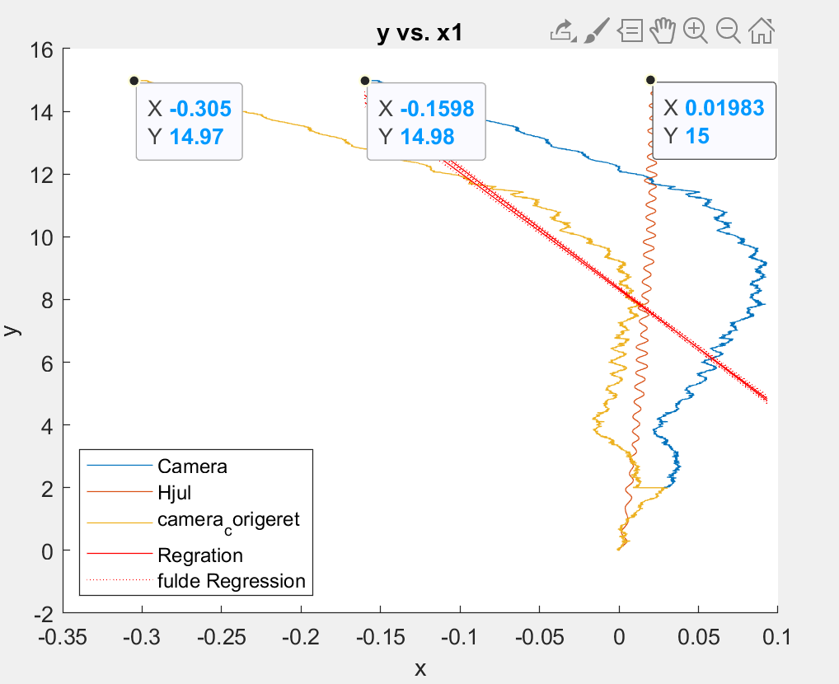 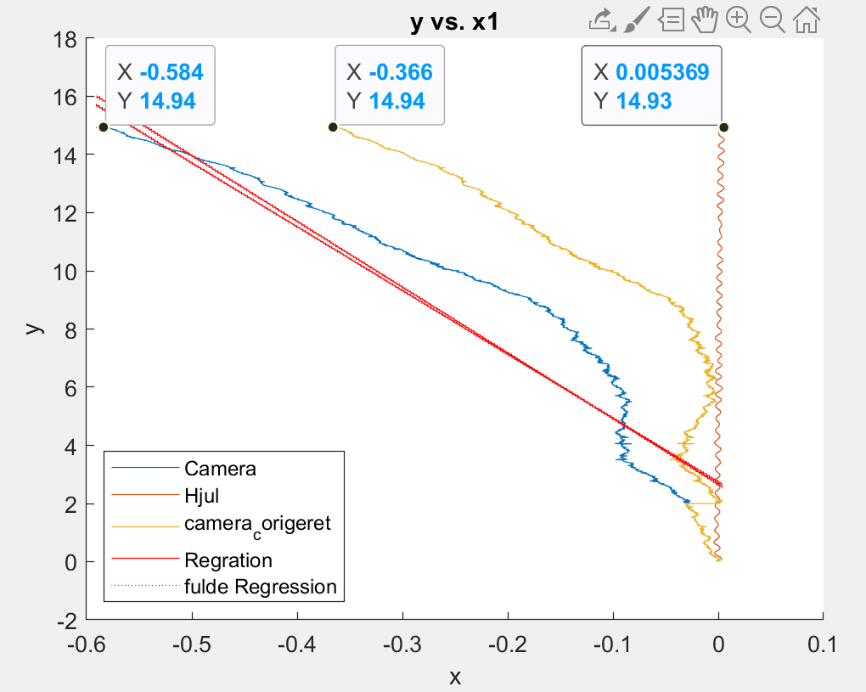

4-6

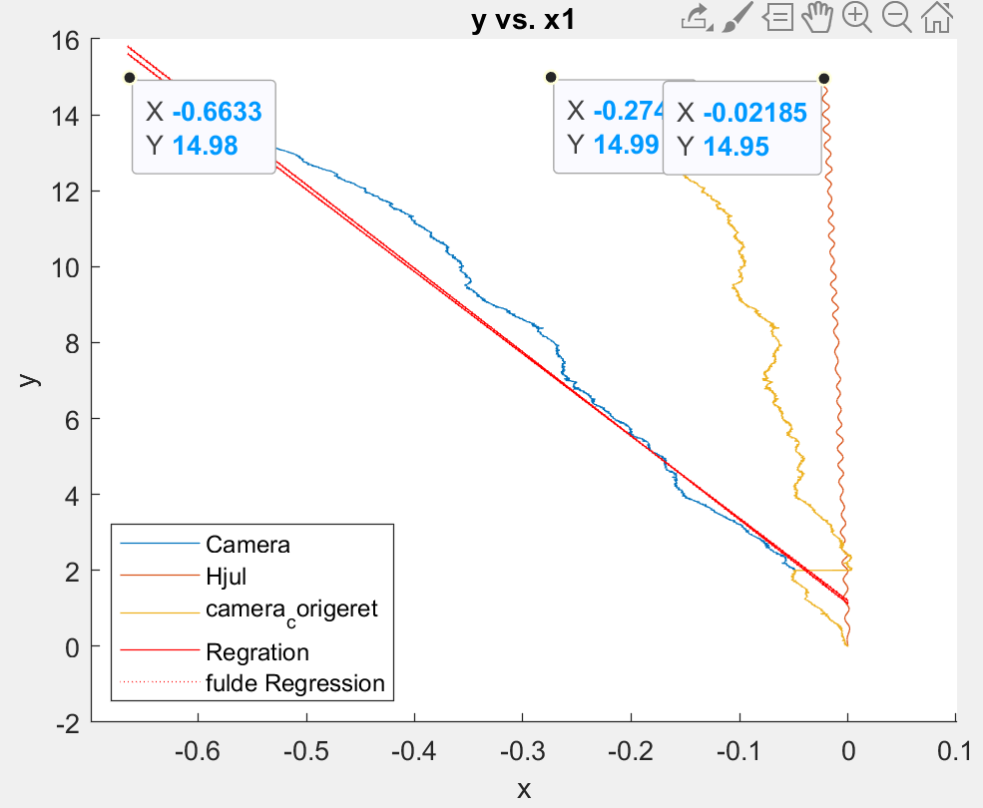 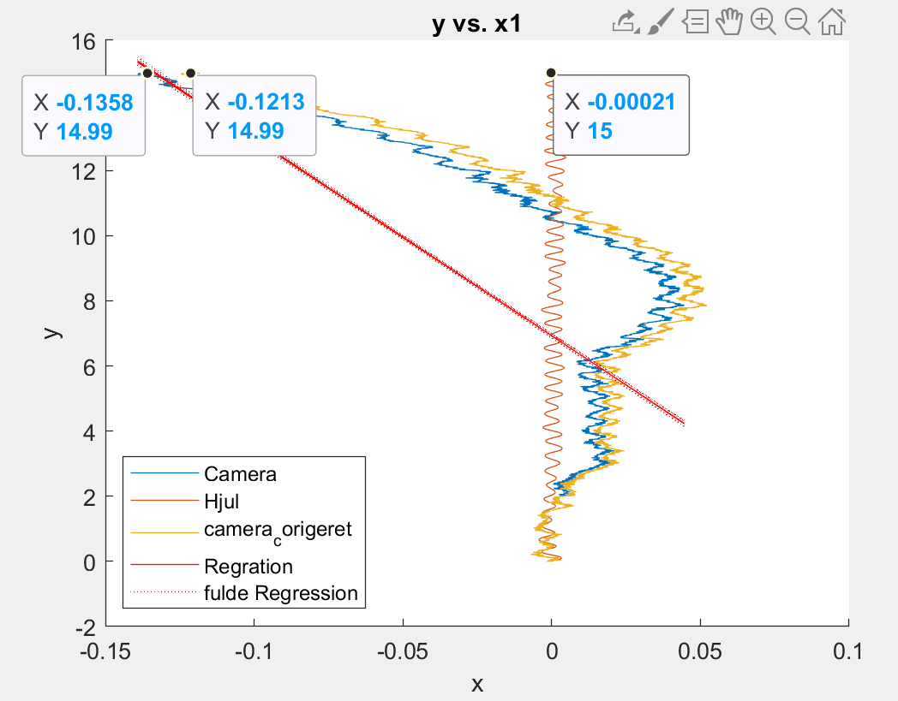 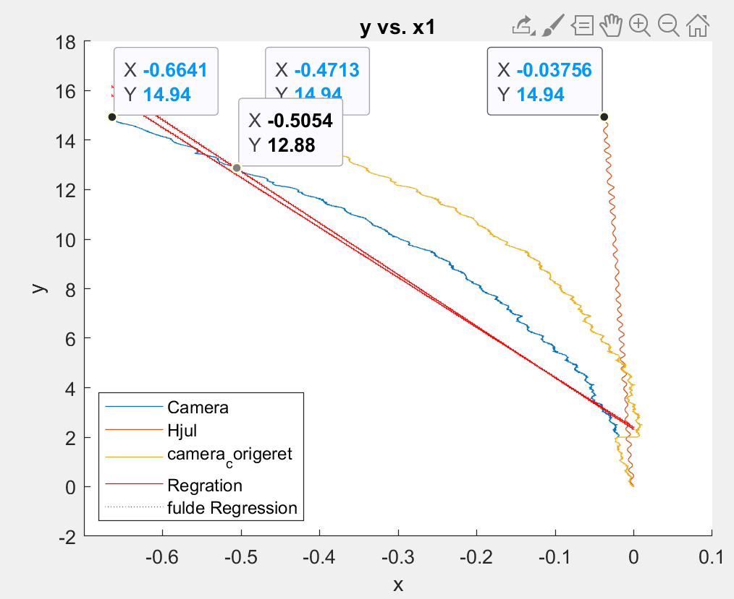

7-9

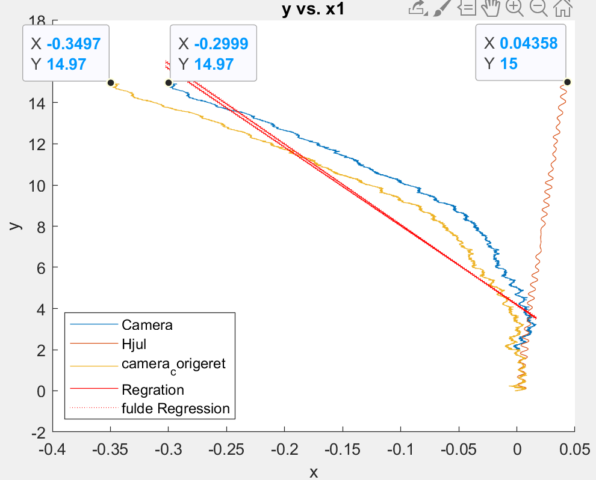 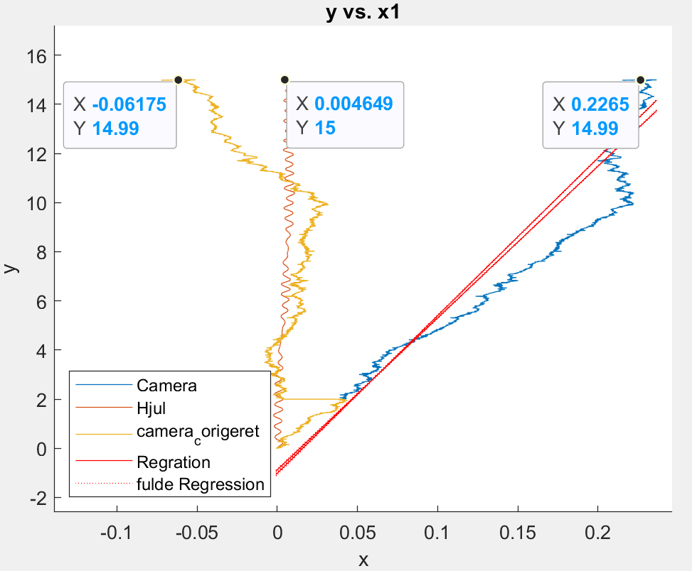 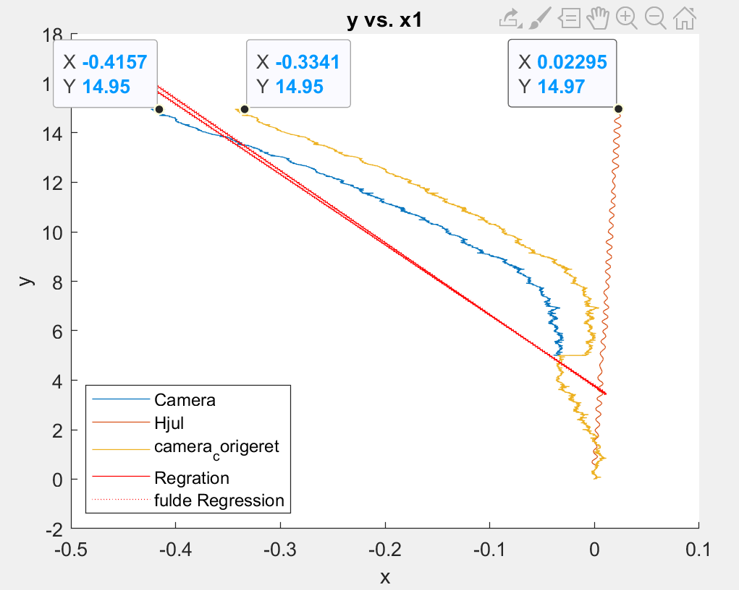

10

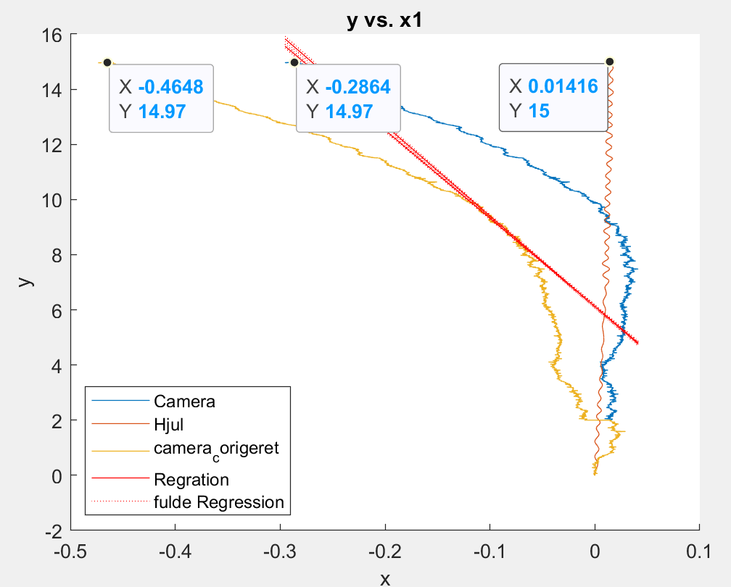

**Actual Deviation From 0**

15 m – Stopped at 14.975m

1, 14.975m, 25cm left

2, 14.975m, 0cm but runs an arc to the left

3, 14.975m, 10cm left

4, 14.975m, 26cm left

5, 14.975m, 12cm left

6, 14.975m, 79 cm left

7, 14.975m, 14cm left

8, 14.975m, 3cm right

9, 14.975m, 30cm left

10, 14.975m, 8cm left

20m ASTA

1-3

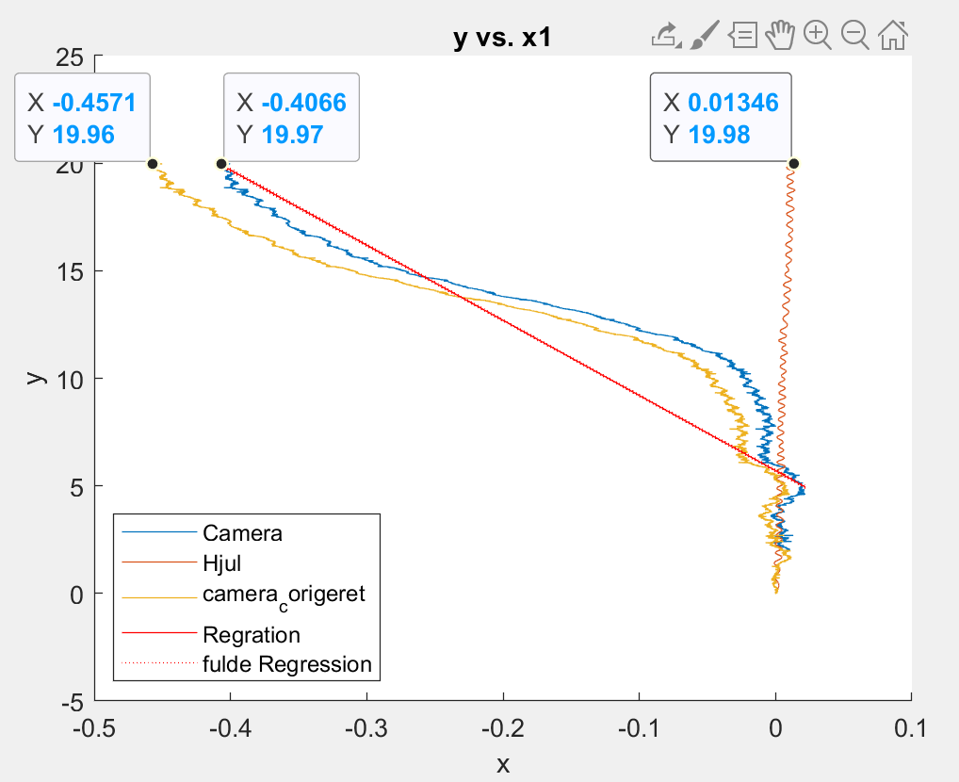 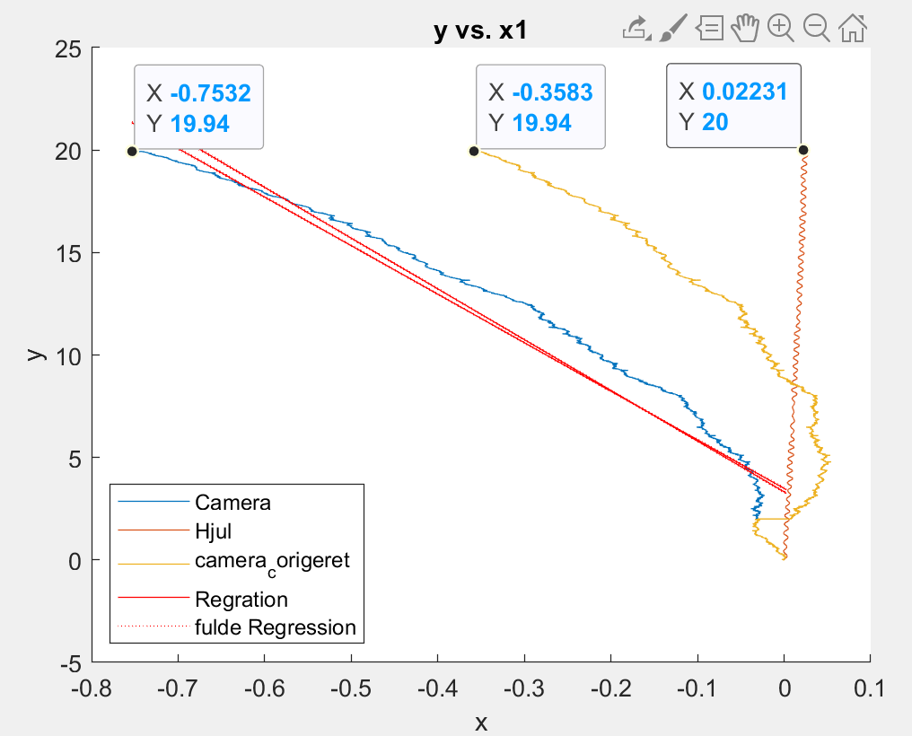 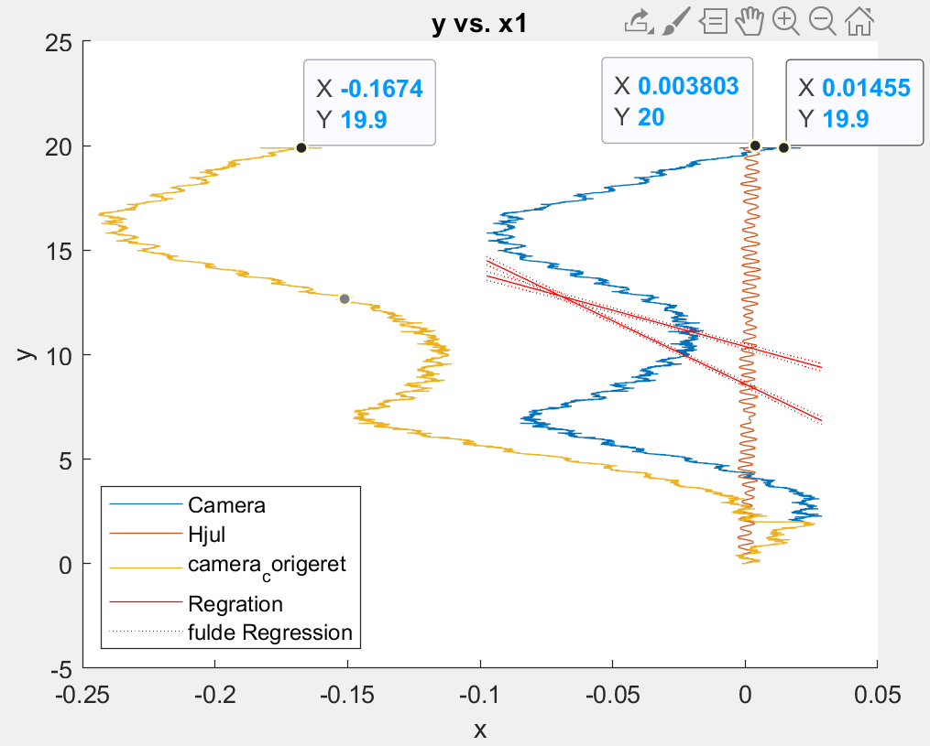

4-6

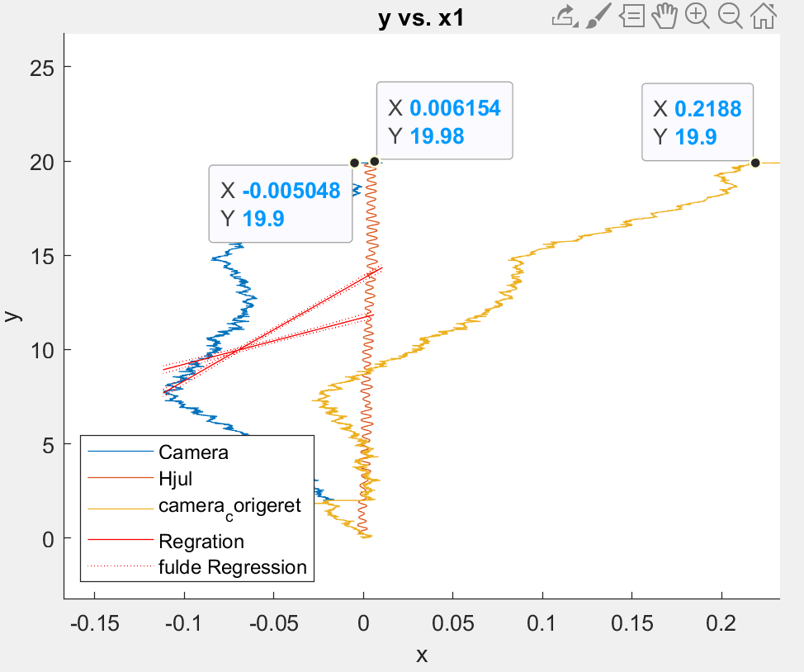 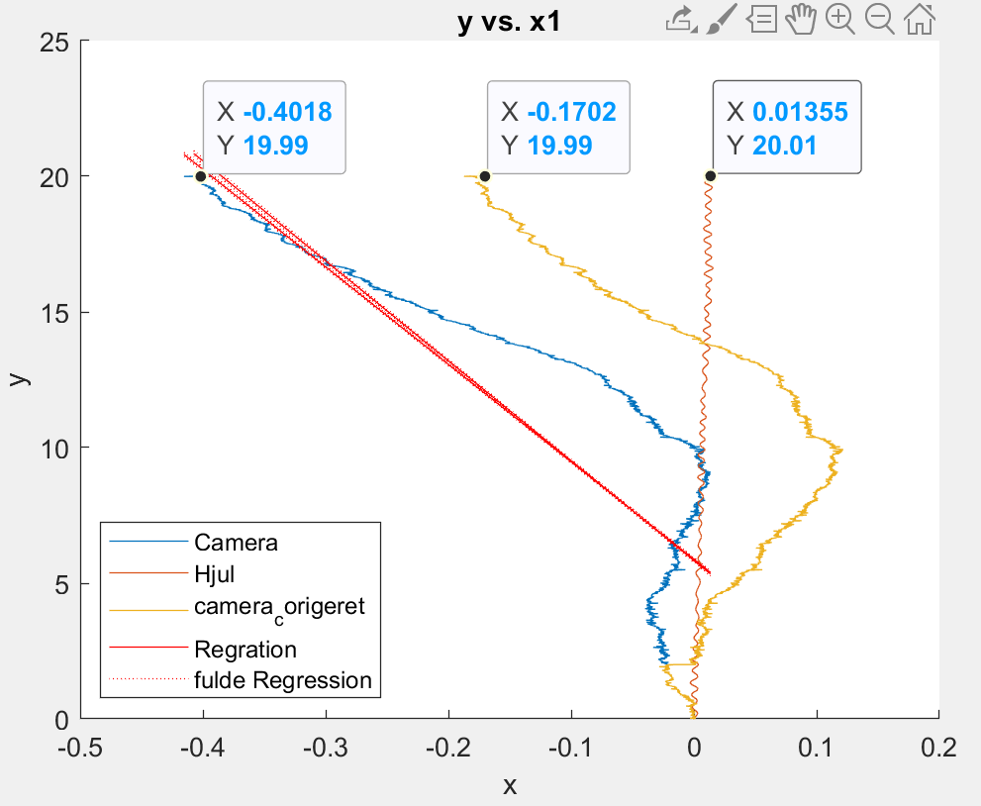 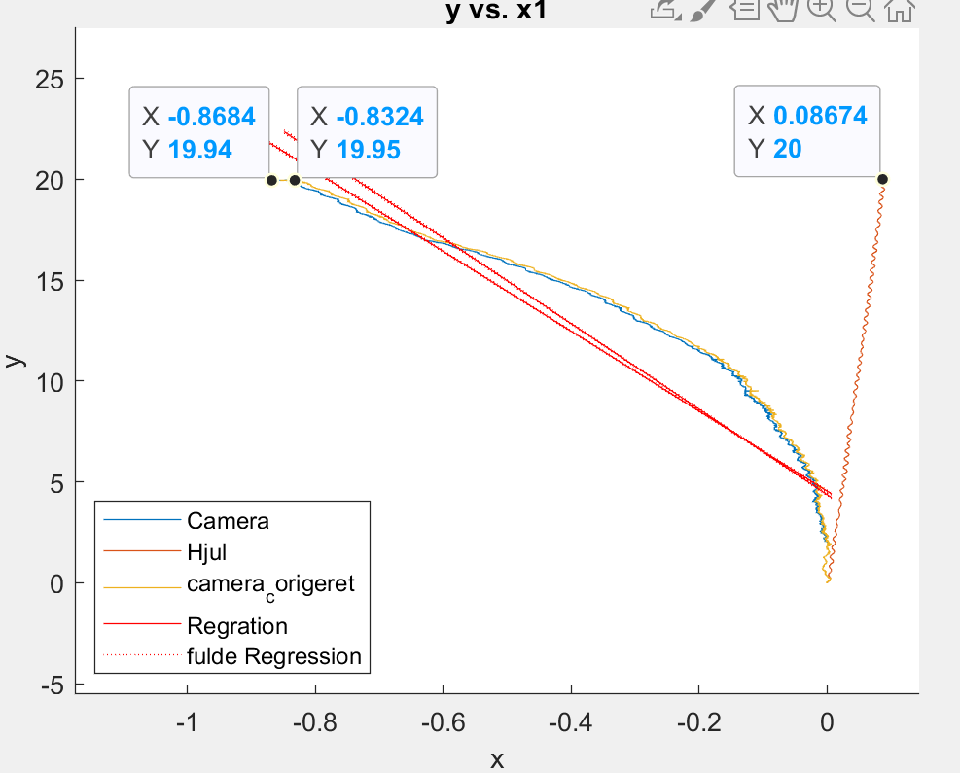

7-9

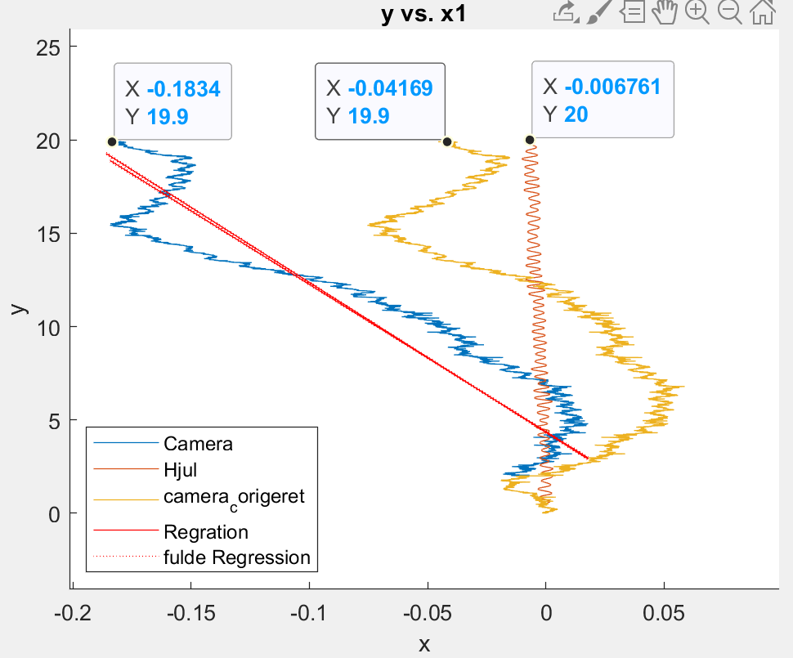 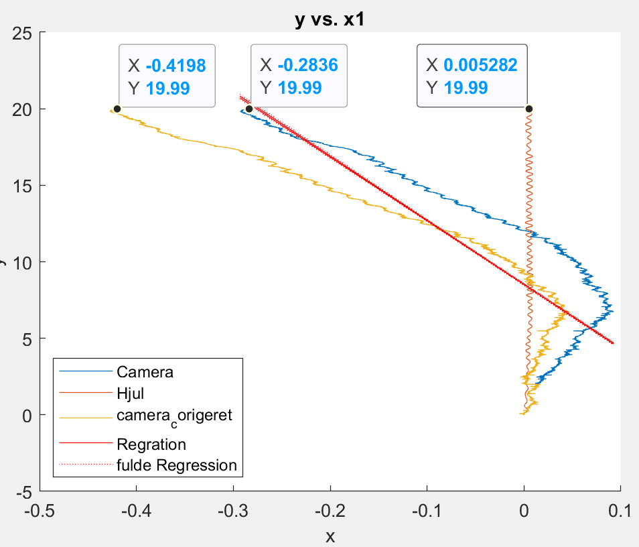 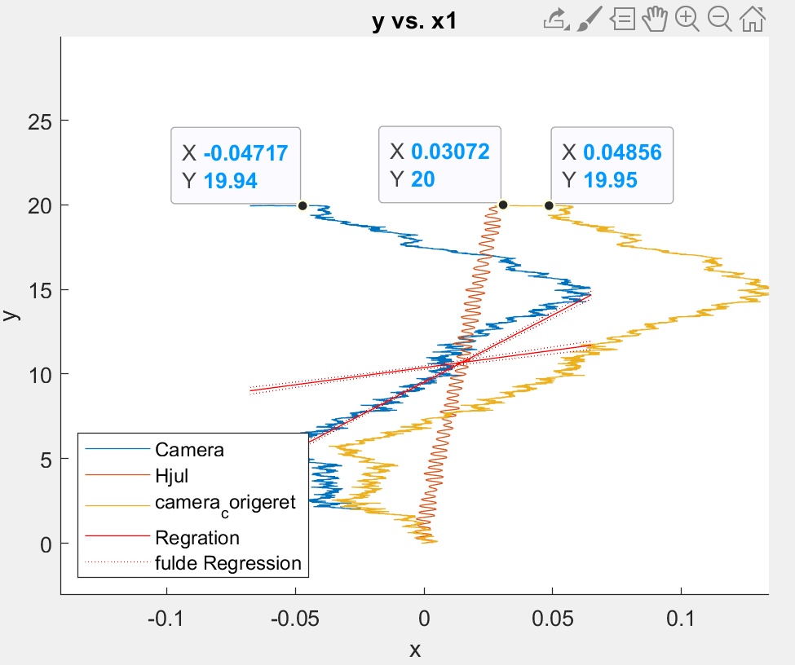

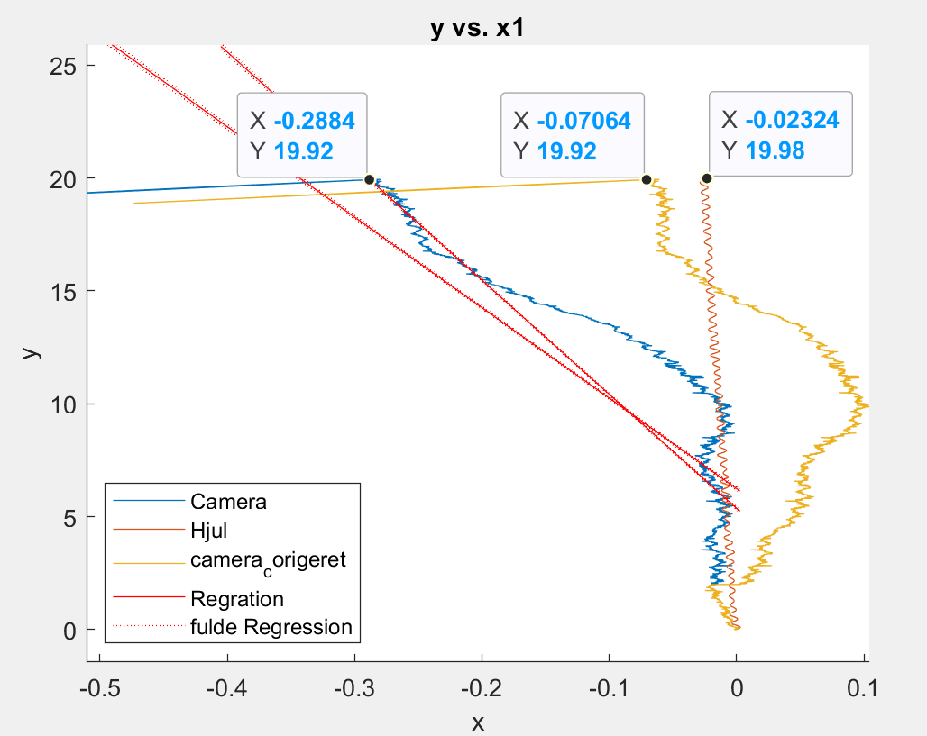10

**Actual Deviation From 0**

1, 19.965m, 1 cm right

2, 19.965m, 34 cm left

3, 19.965m, 5cm right – drove completely straight along the cord until about 17m (hit small bumps)

4, 19.965m, 12cm right

5, 19.965m 7cm right

6, 19.945m , 30cm left

7, 19.96m, 10cm left

8, 19.96, 25cm left

9, 19.955, 30 cm left

10, 19.965, 0 cm

Firkant 2 m med uret

1-3

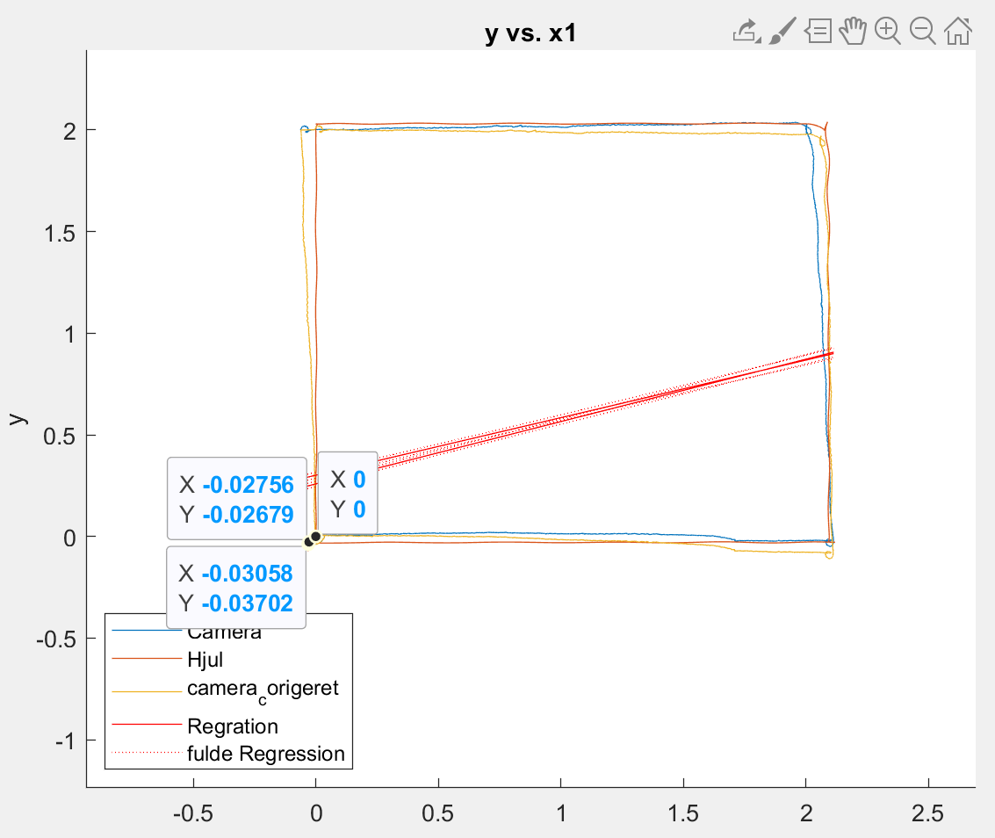 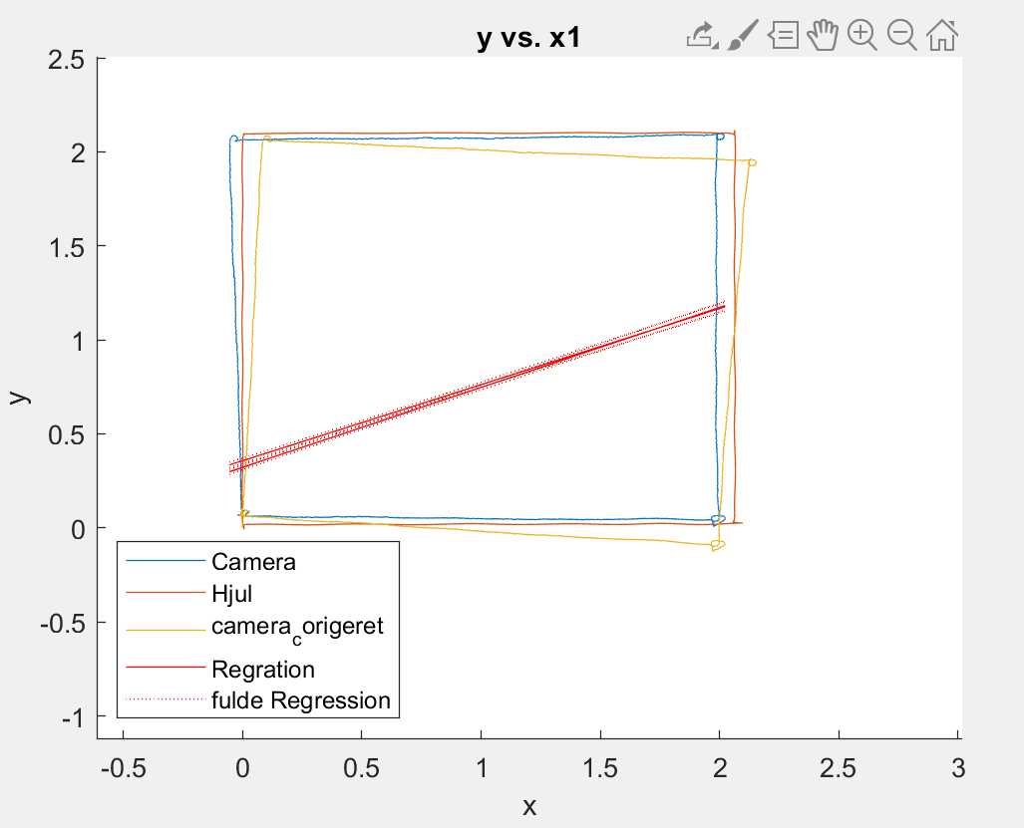 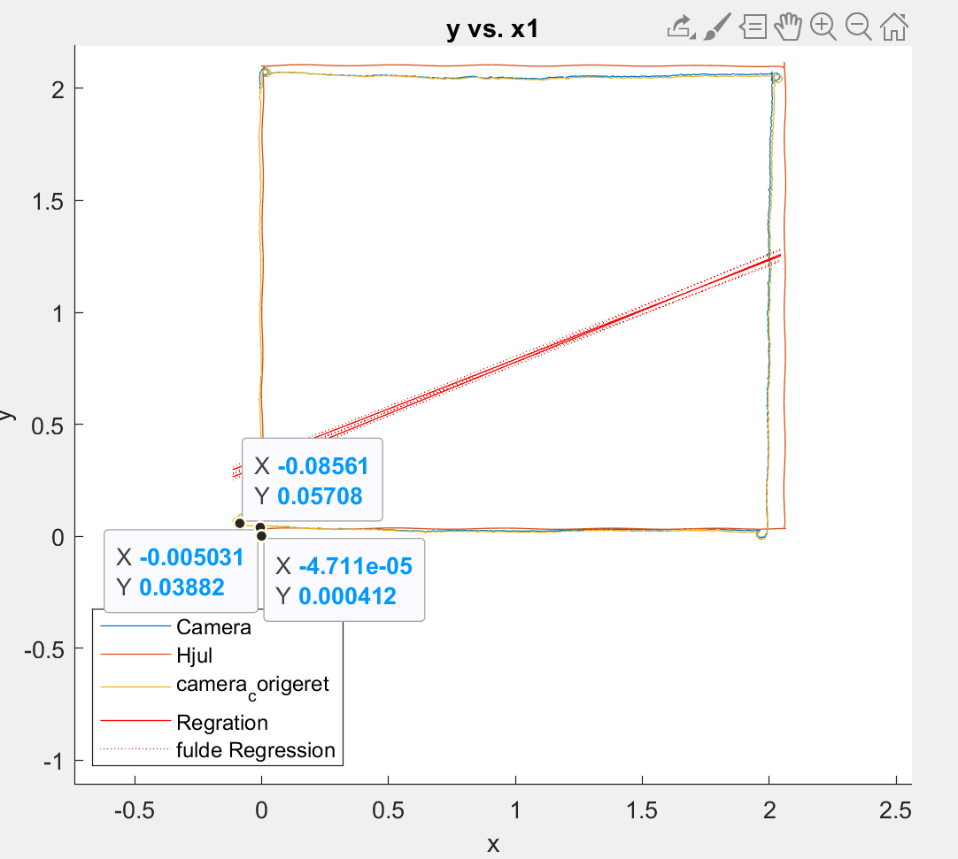

4-5

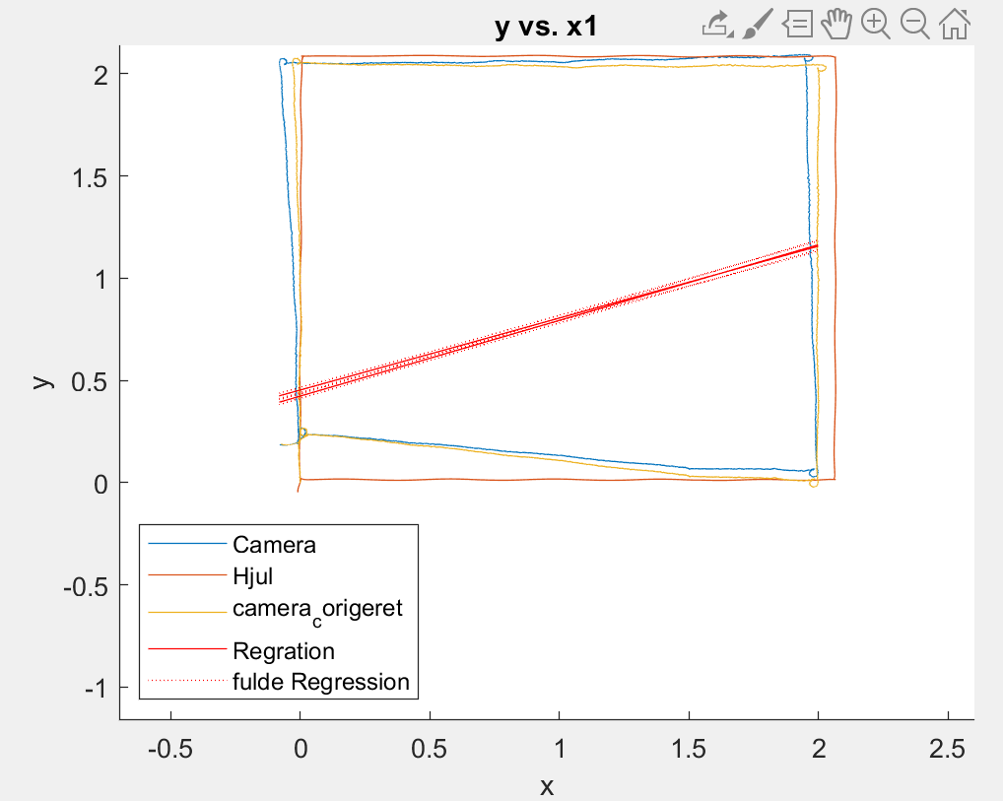 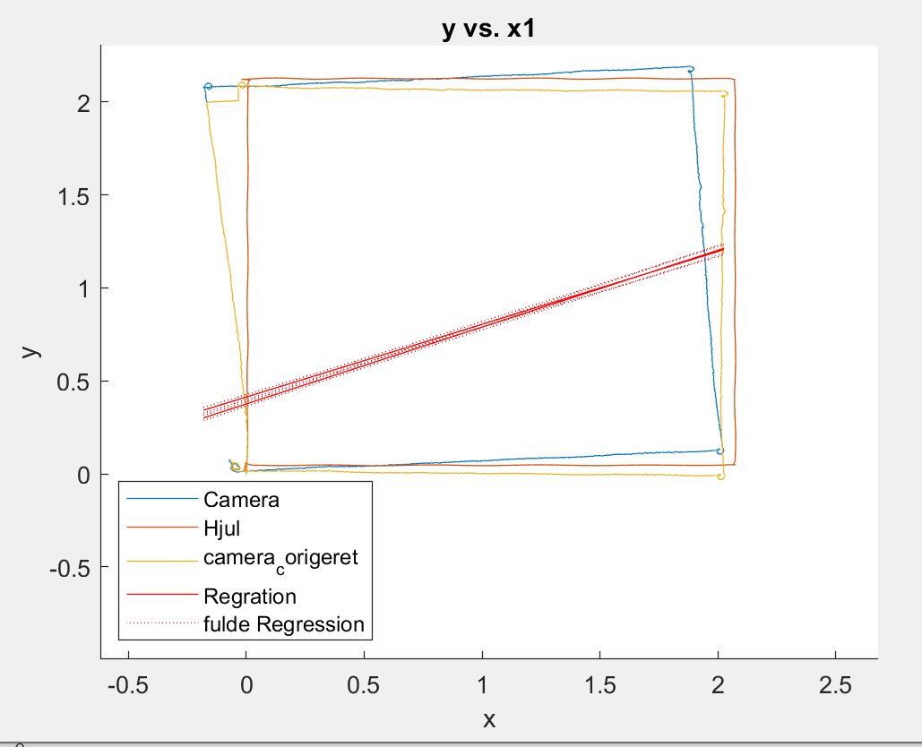

**Actual Deviation From 0**

1, Square clockwise (2 cm to the left - straight ahead)

2, Square 2 clockwise (5 cm to the left and 7 cm to the front)

3, Square 3 clockwise (12 cm to the left and 10 cm in front)

4, Square 4 clockwise (10 left and 10 forward)

5, Square 5 clockwise (11 to the left of 6, 10 in front)

Firkant 2 m mod uret

1-3

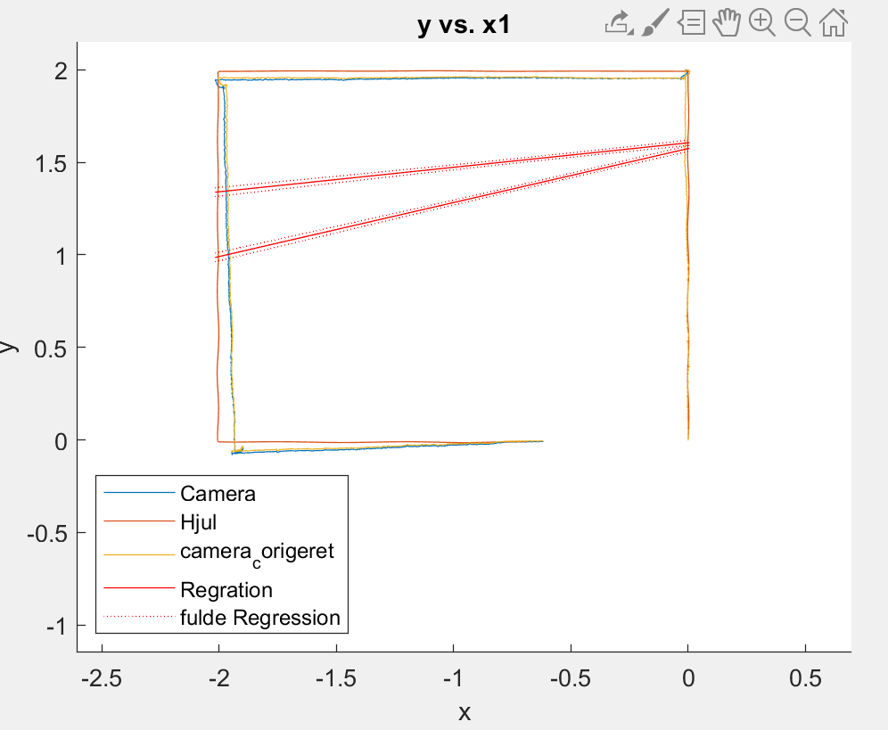 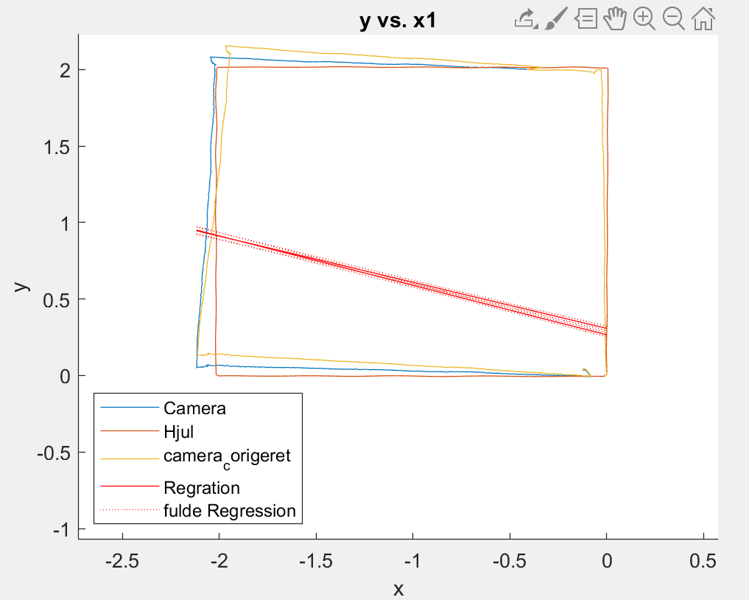 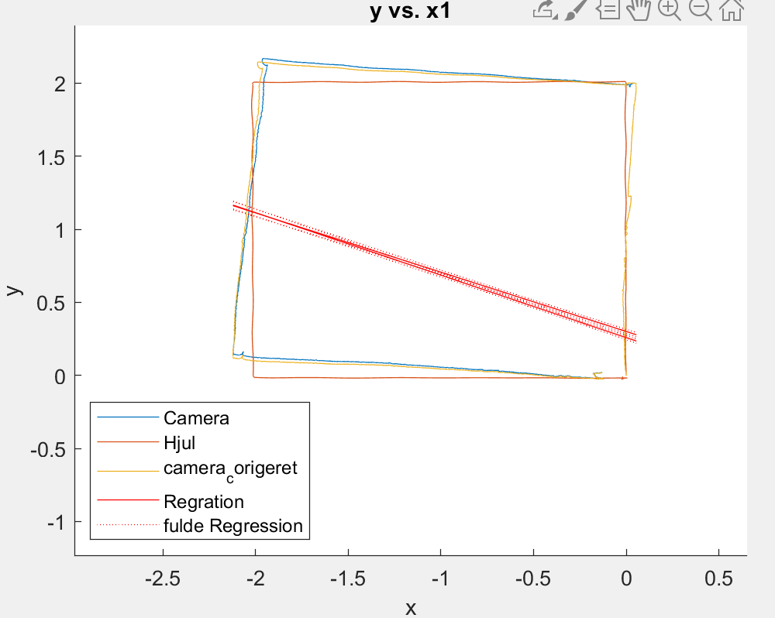

4-5

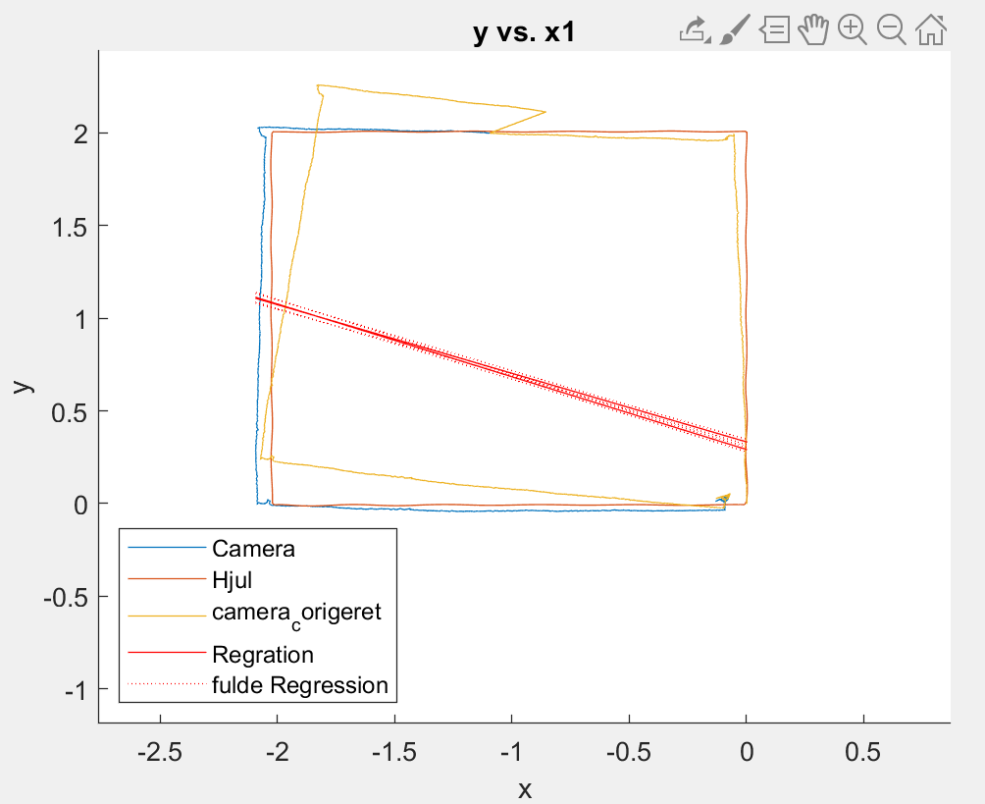 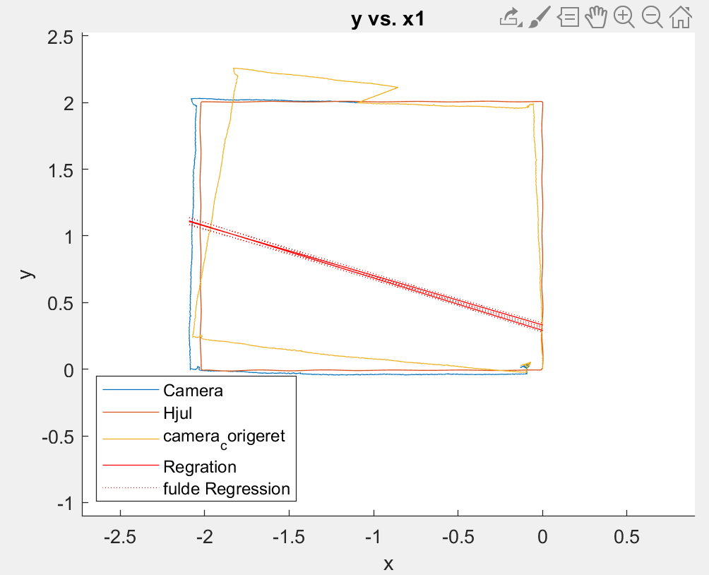

**Actual Deviation From 0**

1, Square 2 with turn, ended 2cm to the left of the cord, but straight on starting position and have the same direction

2, Square 2m turn again to the side, it holds 5cm to the left

3, Square 2m with turn ran the wire over eventually so slightly uneven change in the same direction of (a little over 5cm)

4, Square 2m with turn is 10cm on the right side also 10cm forward

5, Square 2m, 7cm far forward but straight on the cord to the sides.

Vær obs. på at 4 og 5 ikke er de samme

Cirkel 5m i diameter

1-3

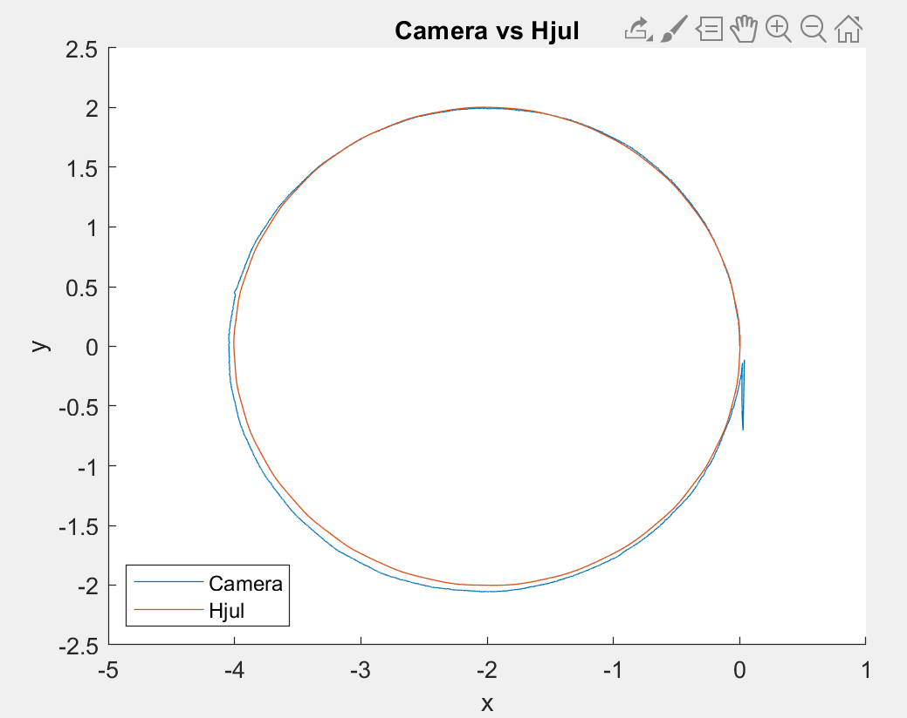 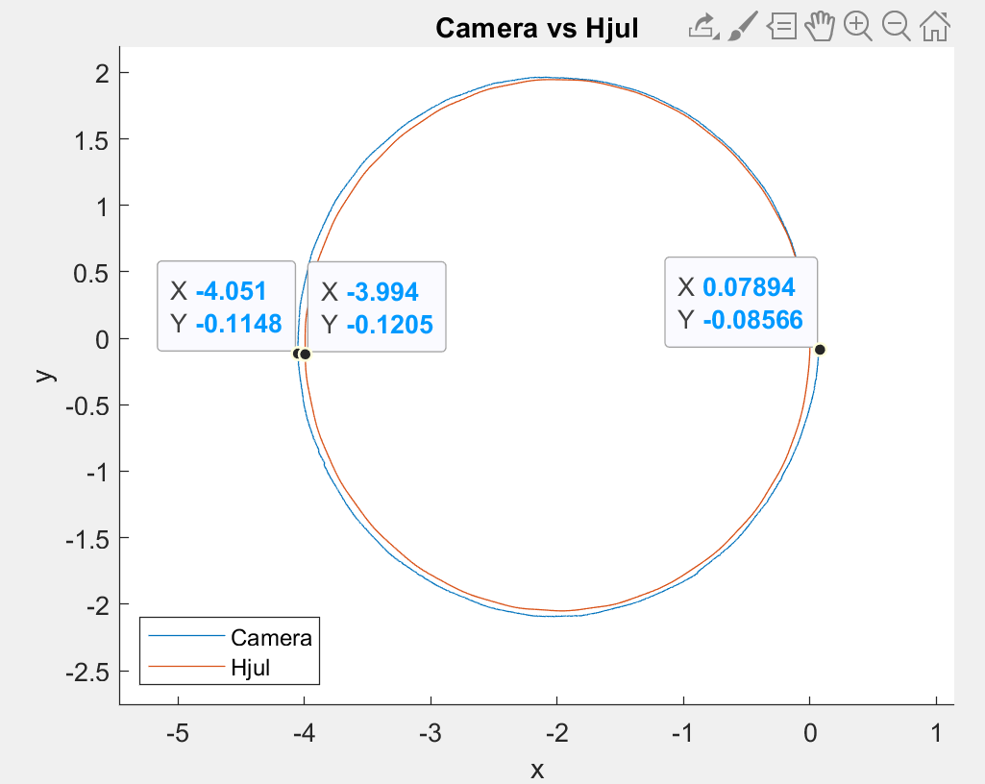 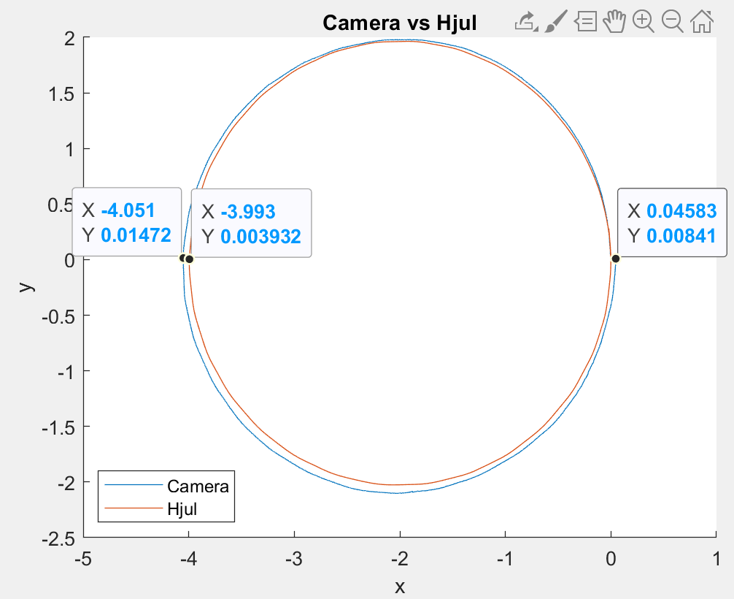

4-5

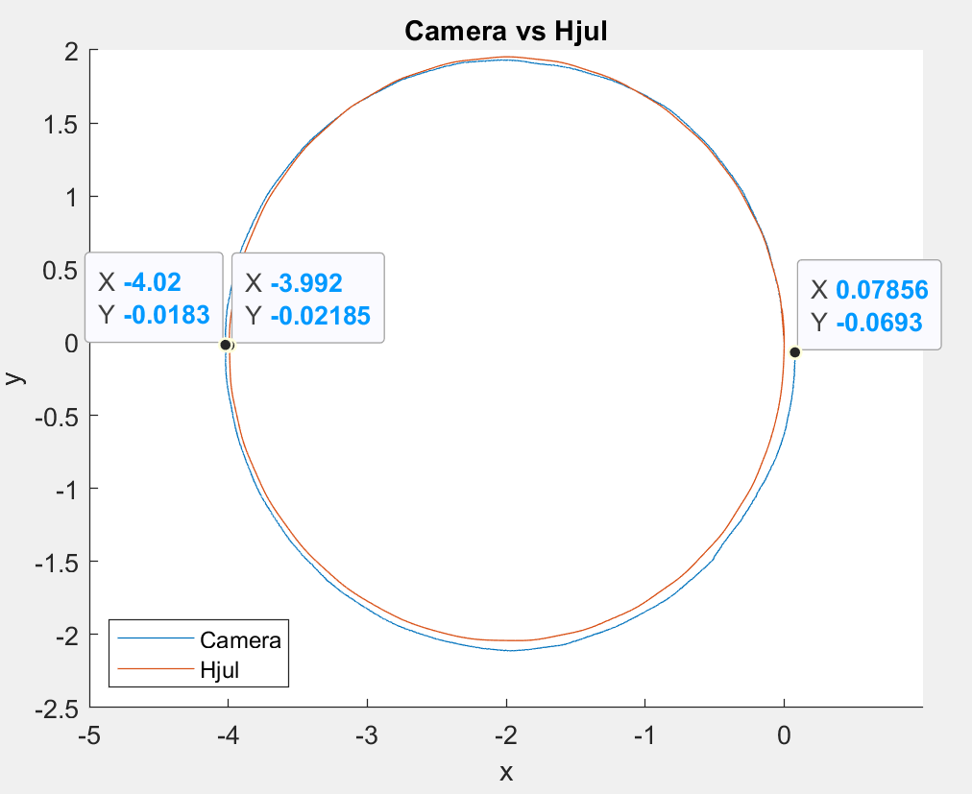 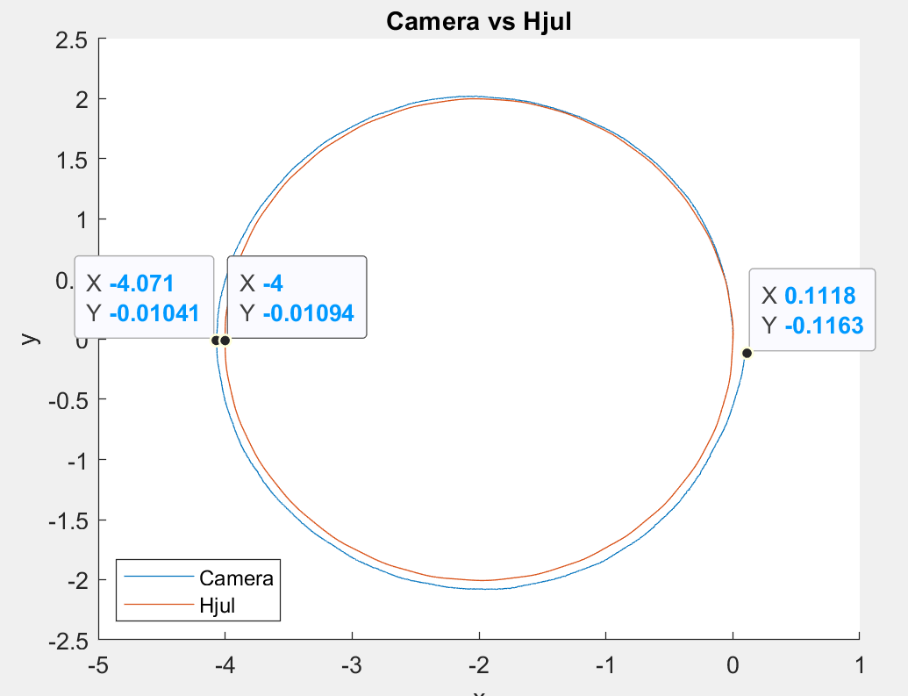

**Actual Deviation From 0**

1, Circle 2 m radius 1 8 cm - I stopped it a little earlier

2, Circle 2m radius 8cm

3, Circle 2m radius 10cm

4, Circle 2m radius 8cm

5, Circle 2m radius 10.5cm

Cirkel 10m diameter

1-3

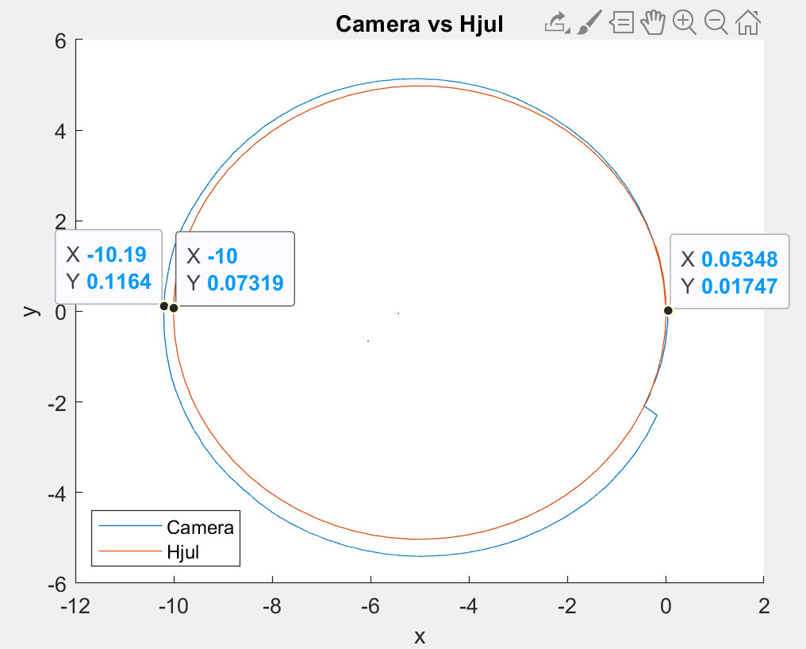 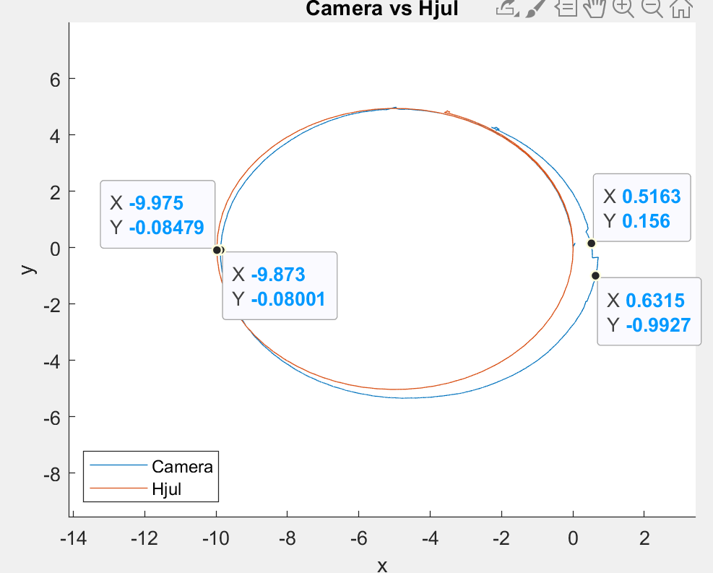 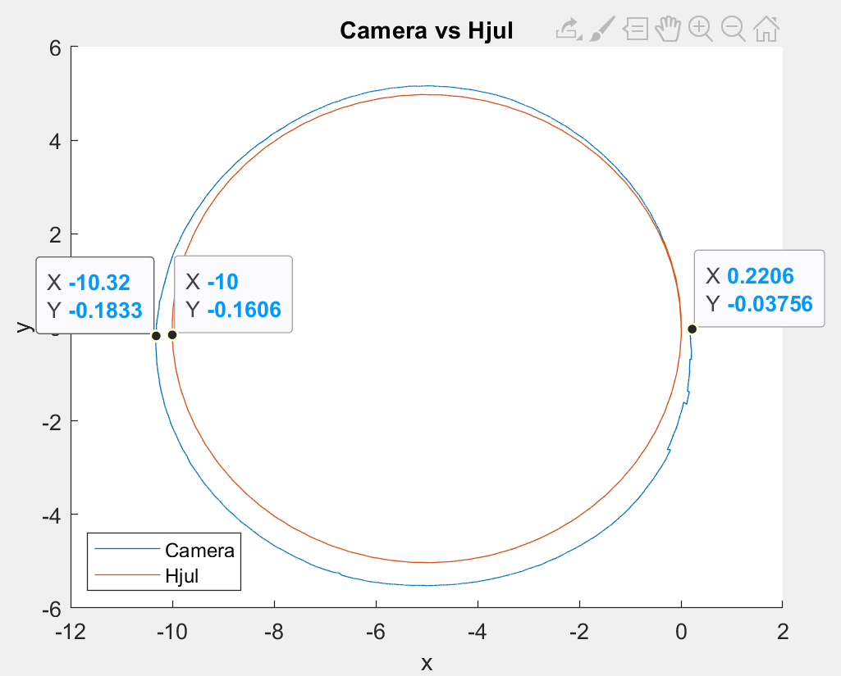

4-5

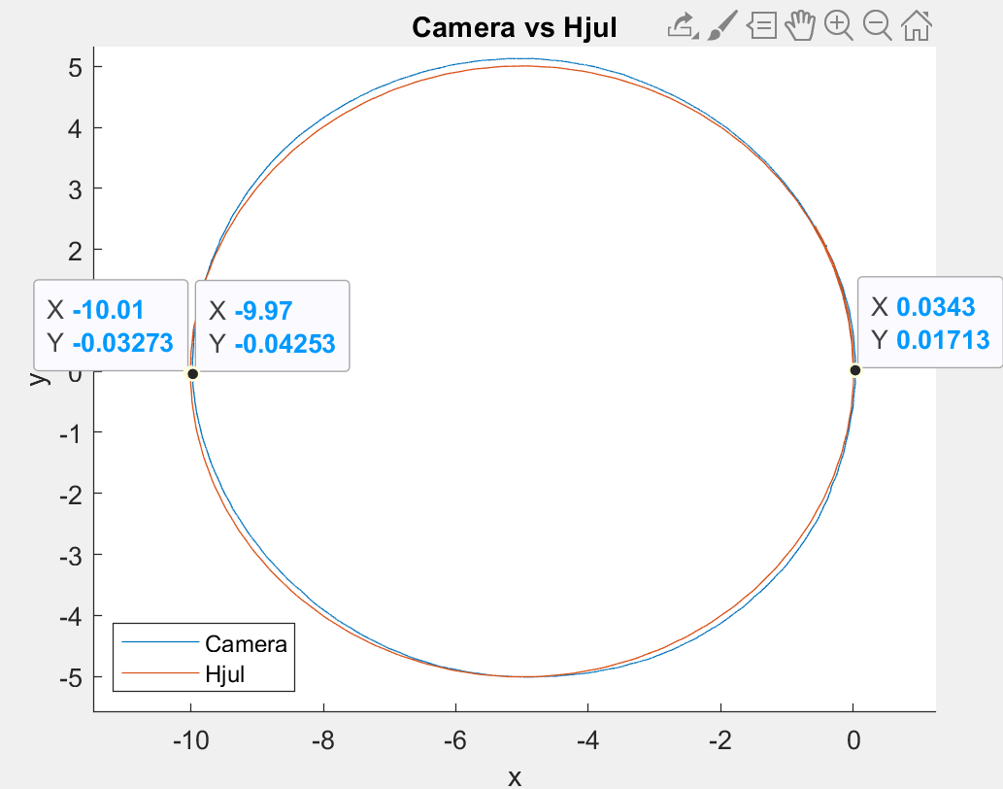 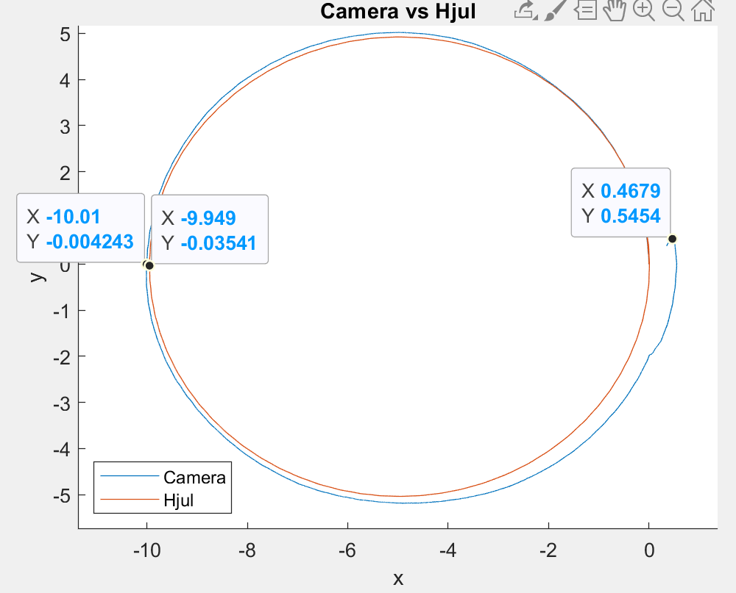

**Actual Deviation From 0**

1, Circle 5m radius 10cm

2, Circle 5m radius a little more 10cm

3, Circle 5m radius 19cm

4, Circle 5m radius 8cm

5, Circle 5m radius 19cm

Cirkel bare kørt rundt 2 m radius = 4m diameter

1-2

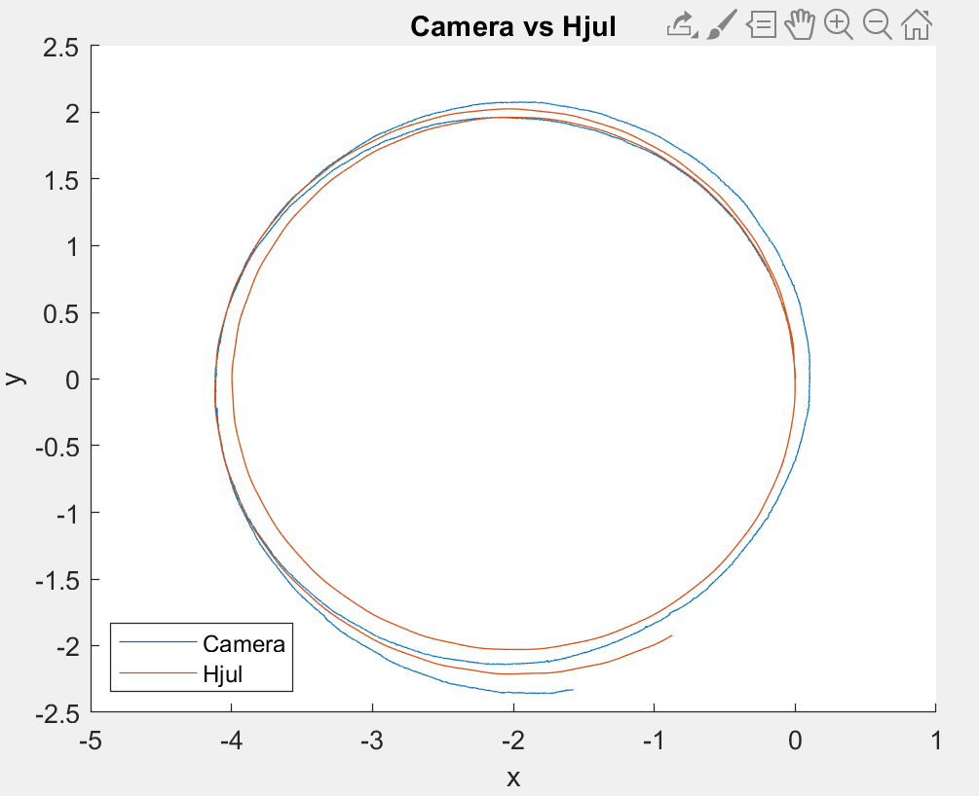 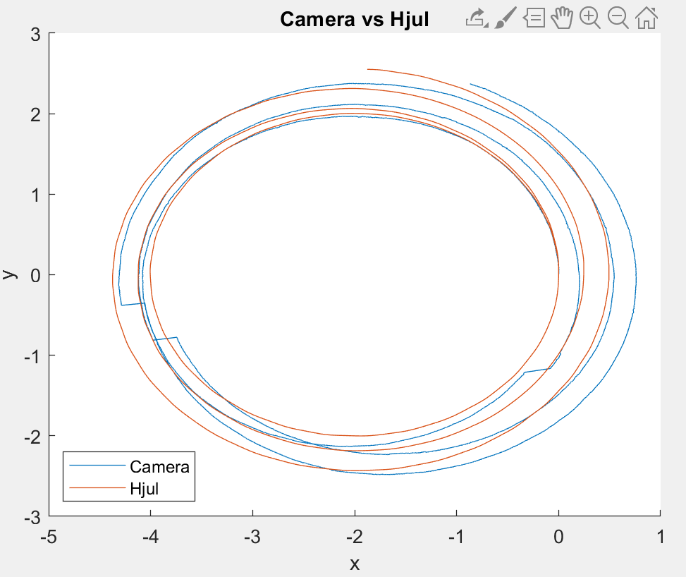

10 m lavet som ekstra

1-3

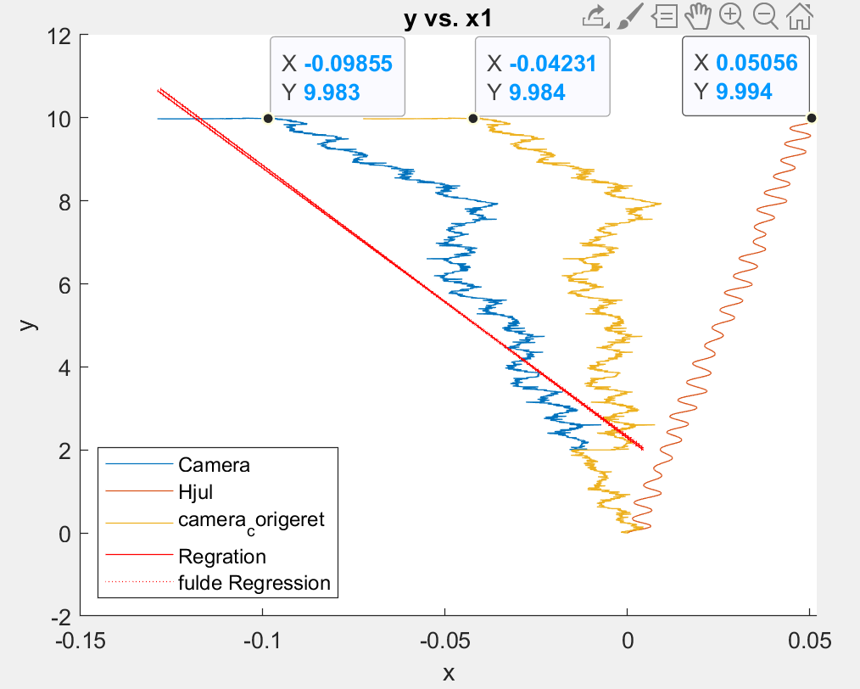 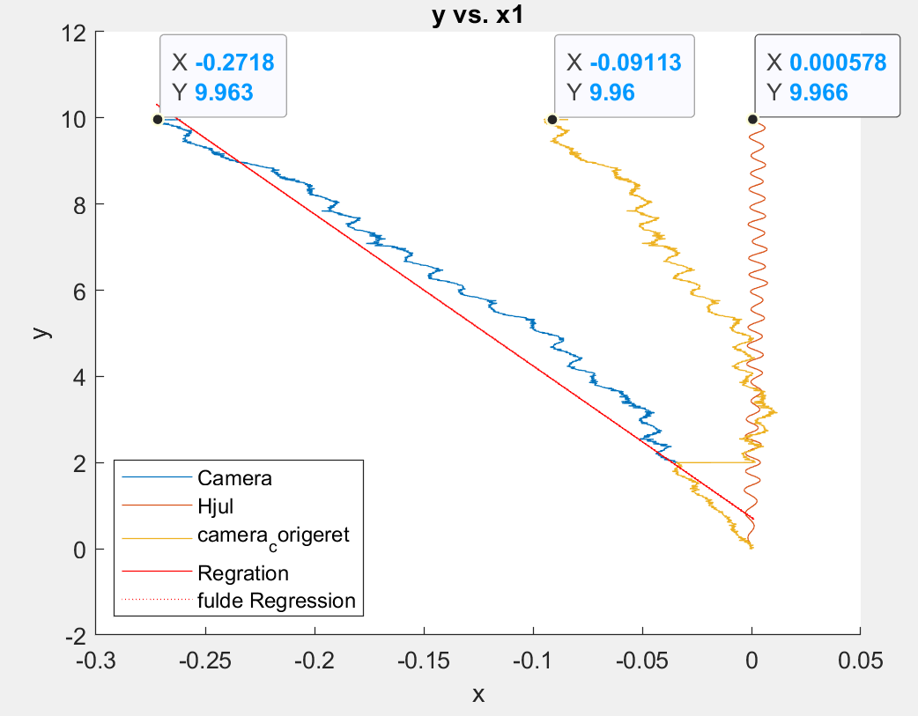 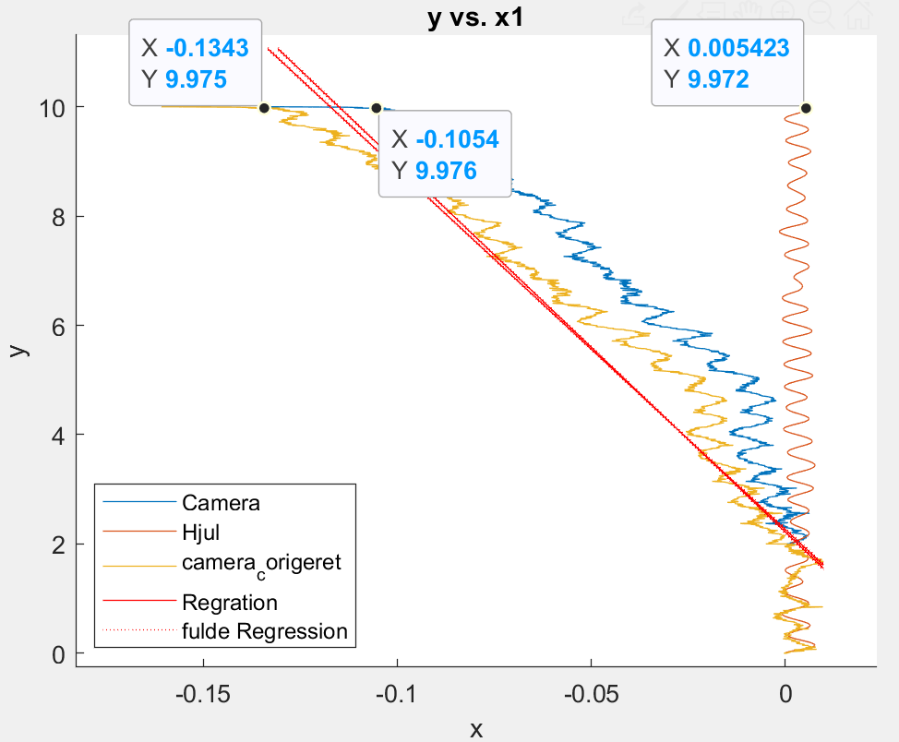

4-6

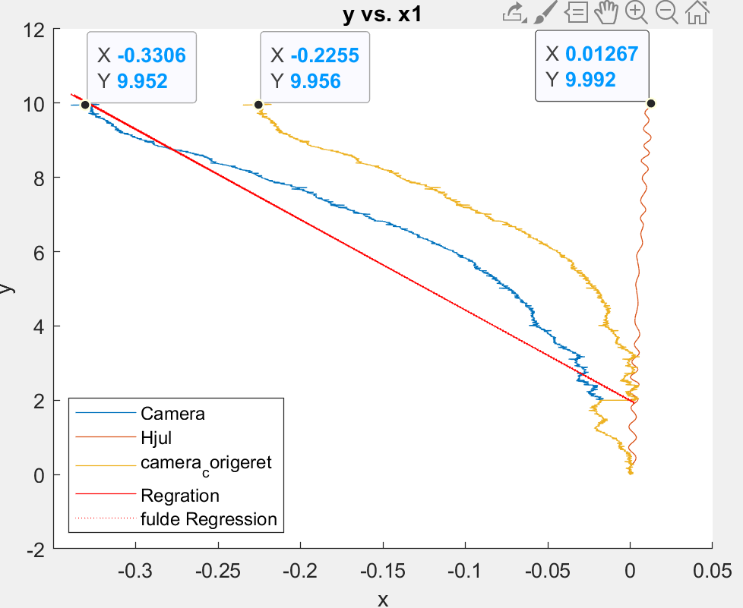

**Actual Deviation From 0**

1, 10m made extra 0cm - completely straight

2, 10m made extra 27.5cm to the left

3, 10m made extra 0cm - completely straight

4, 10m made extra 21cm to the left

10m med hund til at rette ind

1-3

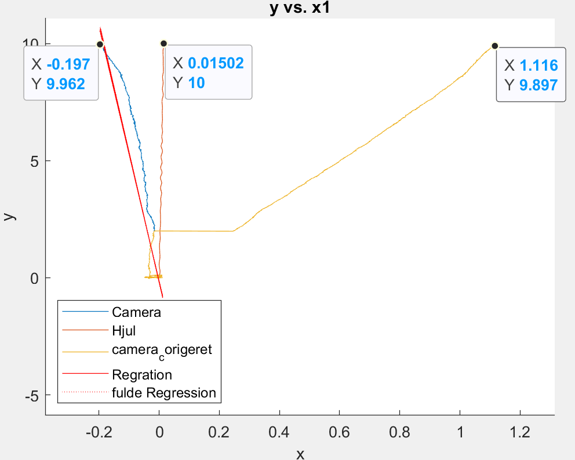 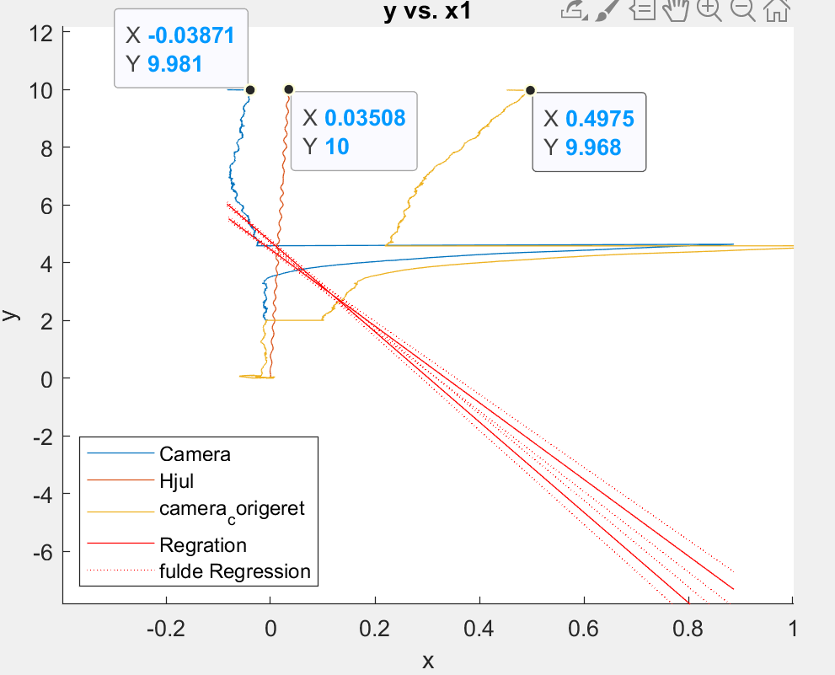 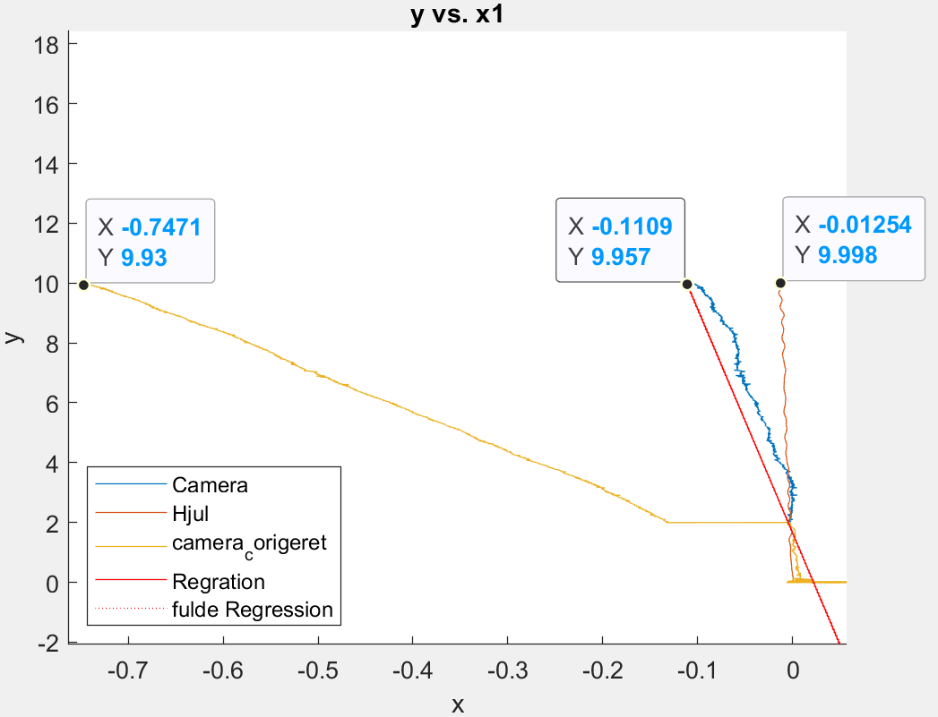

4-6

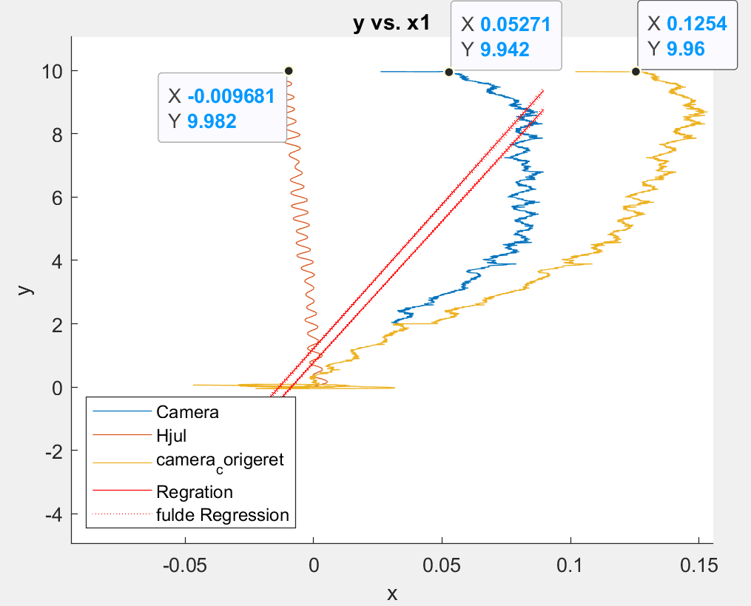 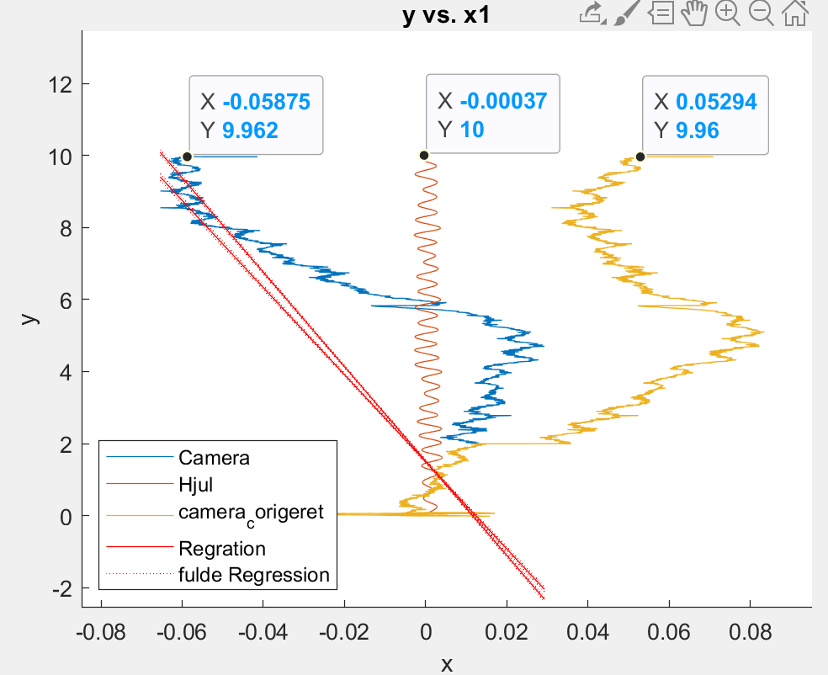 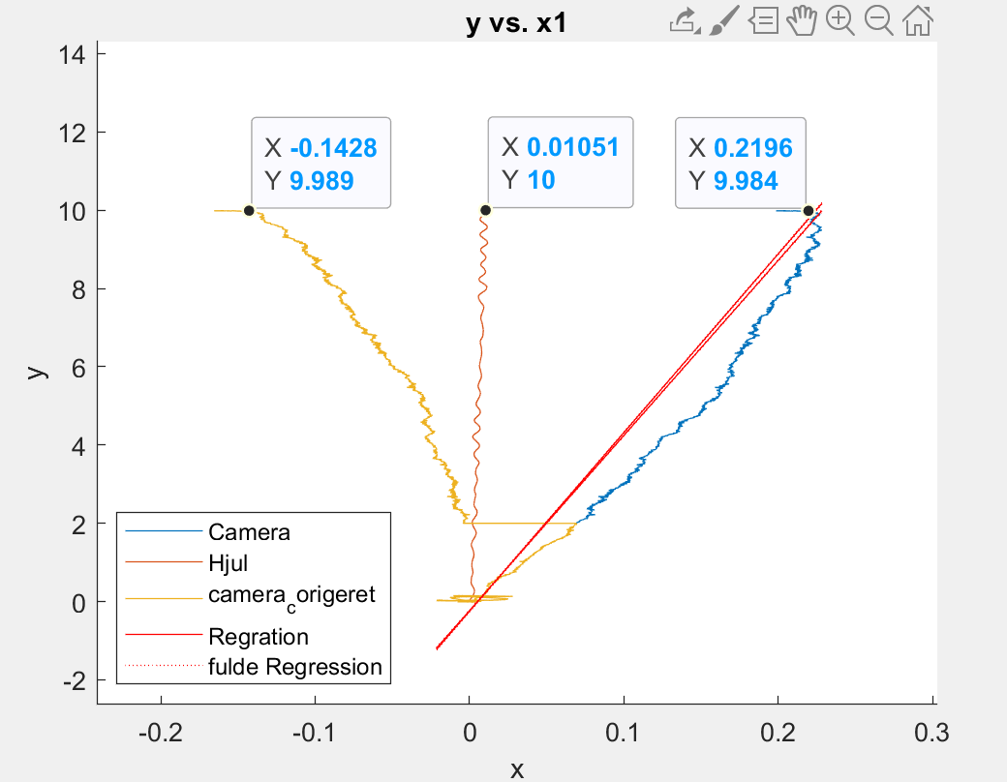

7-9

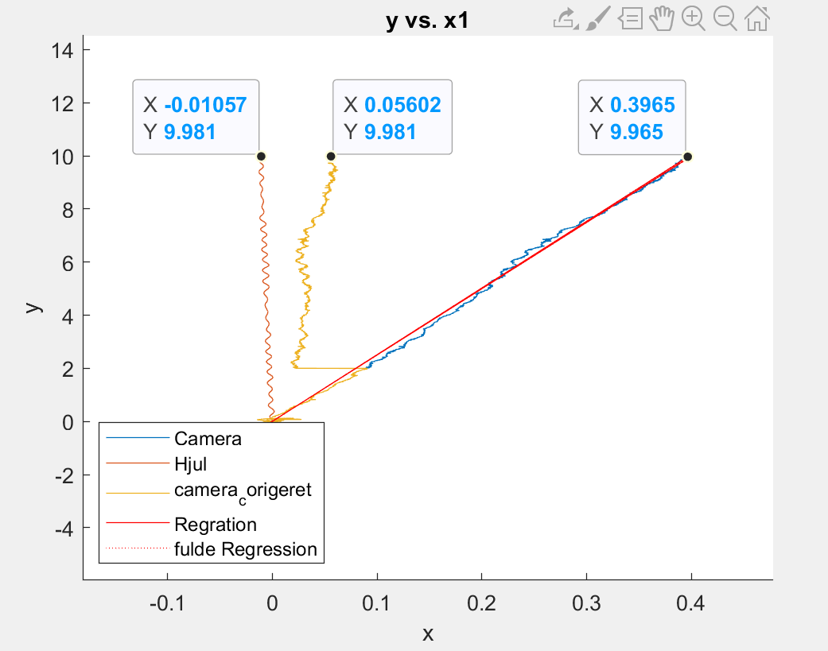 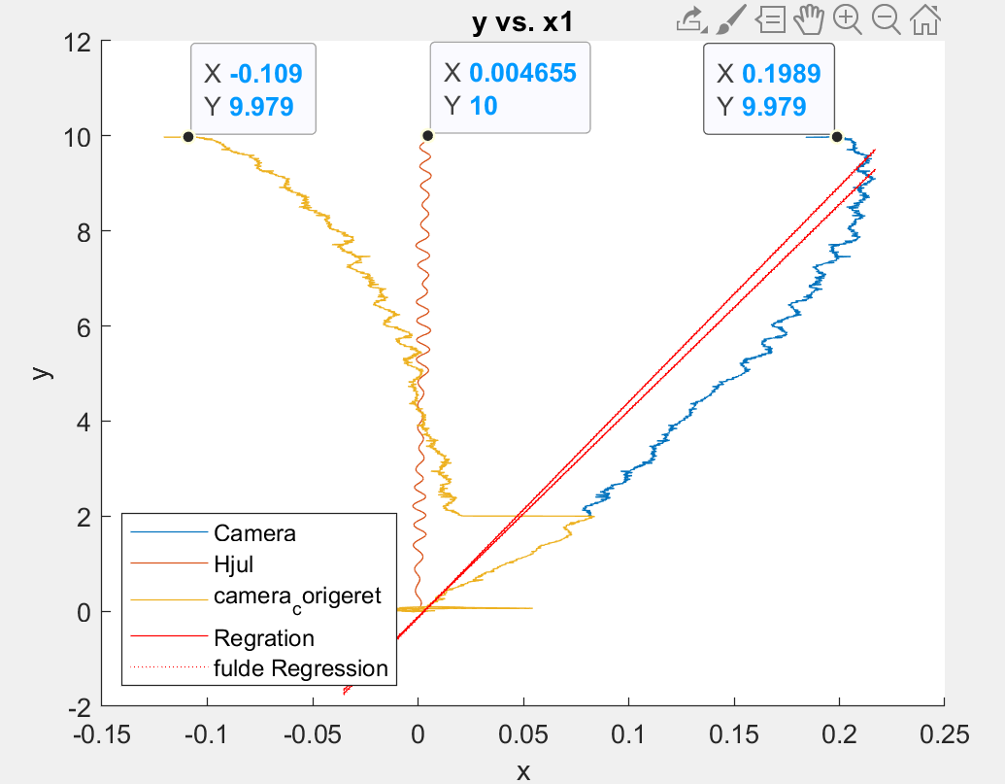 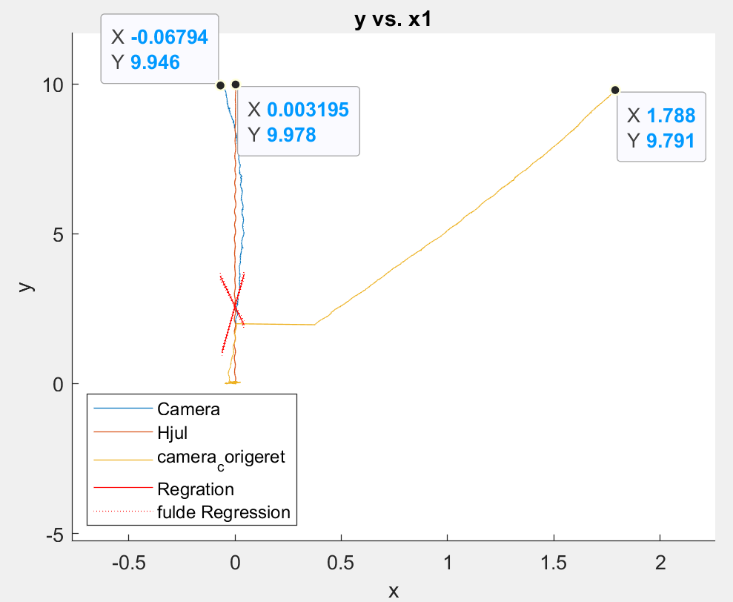

10

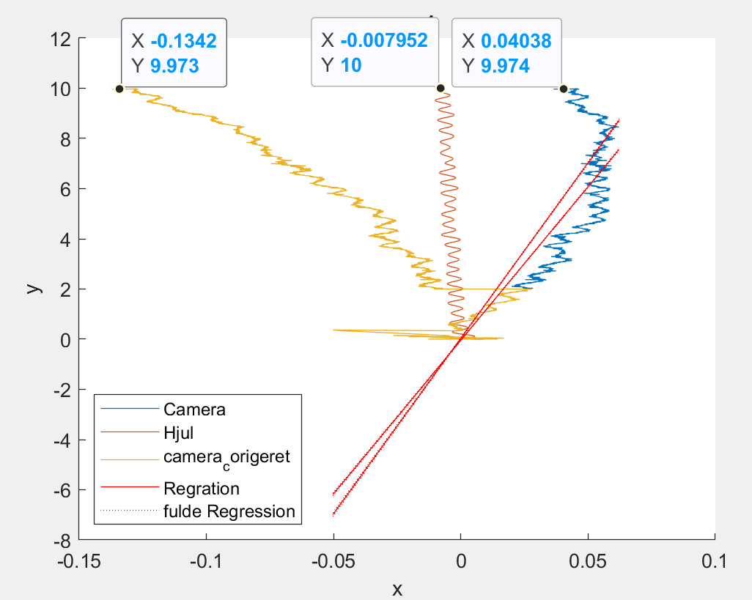

**Actual Deviation From 0**

1, 10 m dog 19,975 20 cm to the left - started a little skewed to the left

2, 10 m dog 19.98 2.5cm to the right - followed the leash more or less all the way

3, 10 m dog 19.98 24 cm to the left - started a little skewed to the left

4, 10 m dog 19.98 5 cm to the right - started a little crooked to the right

5, 10 m dog 19.98 11 cm to the left

6, 10 m dog 19.98 4.5 cm to the right - started a little crooked to the right

7, 10 m dog 19.98 10 cm to the right

8, 10 m dog 19.98 5 cm to the right - started a little crooked to the right

9, 10 m dog 19.98 22 cm to the left

10, 10 m dog 19.98 6 cm to the left

10m Fast

1-3

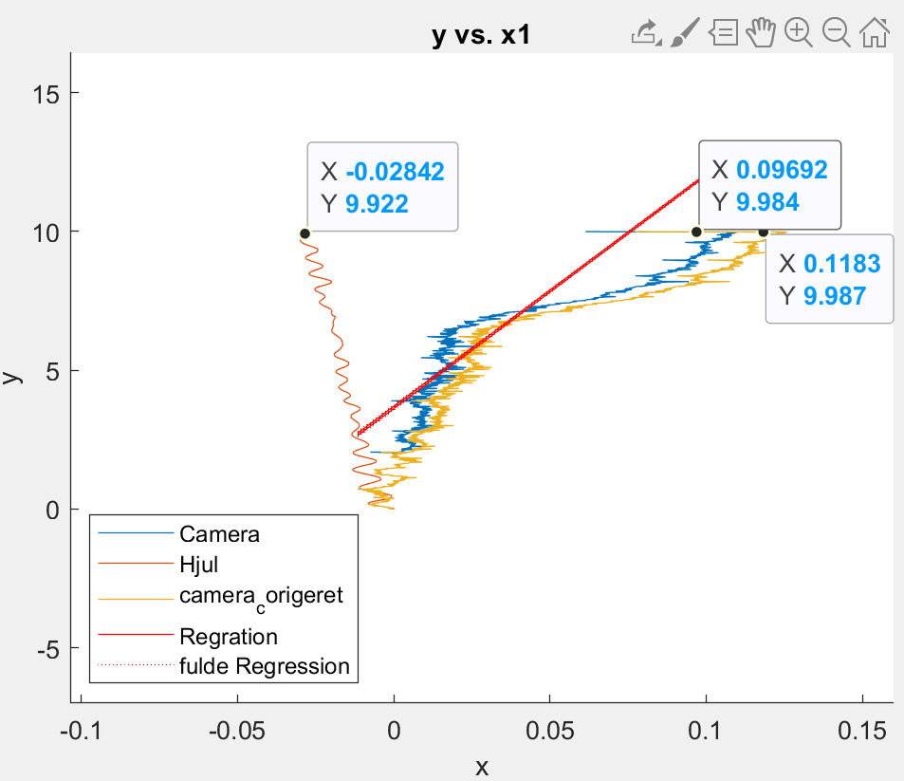 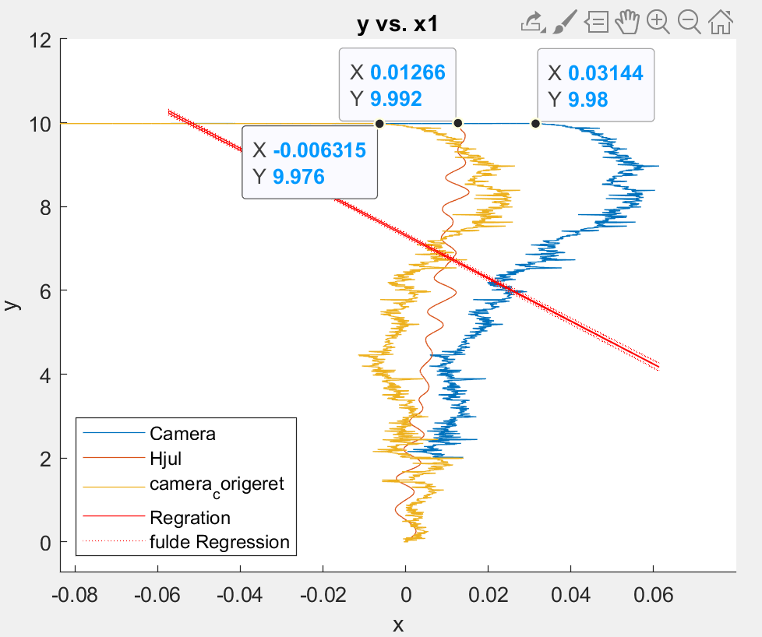 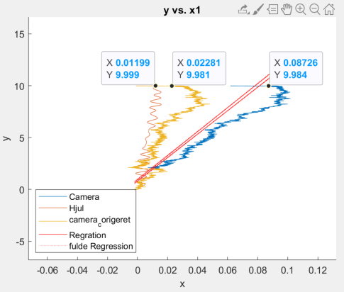

4-6

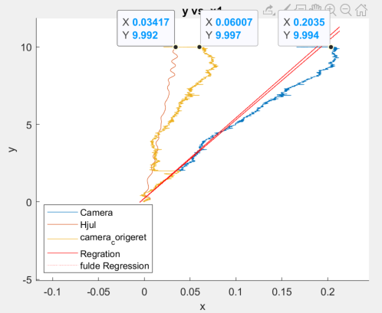 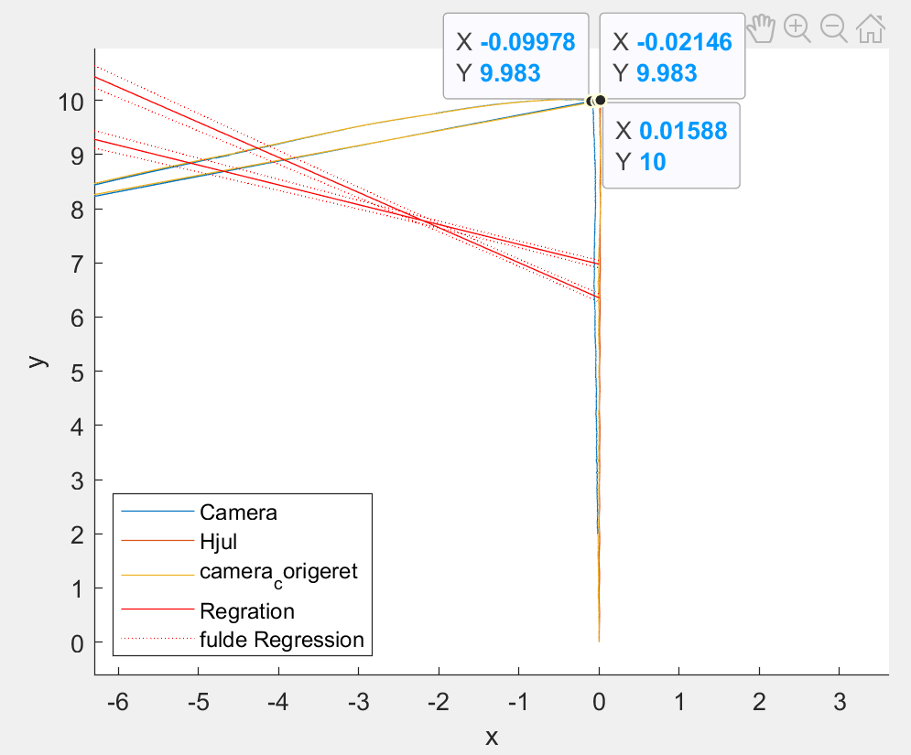 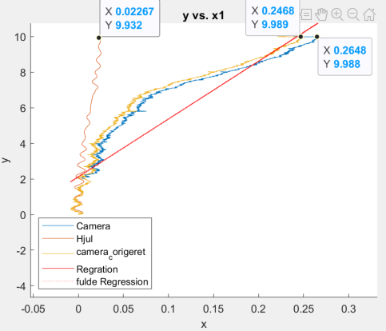

7-9

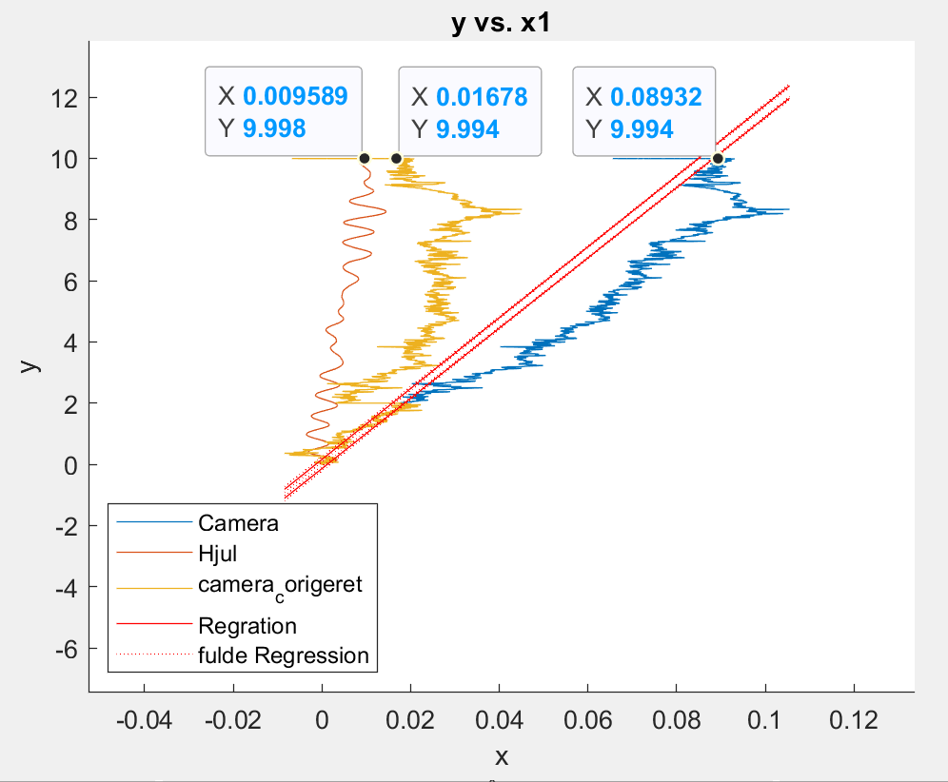 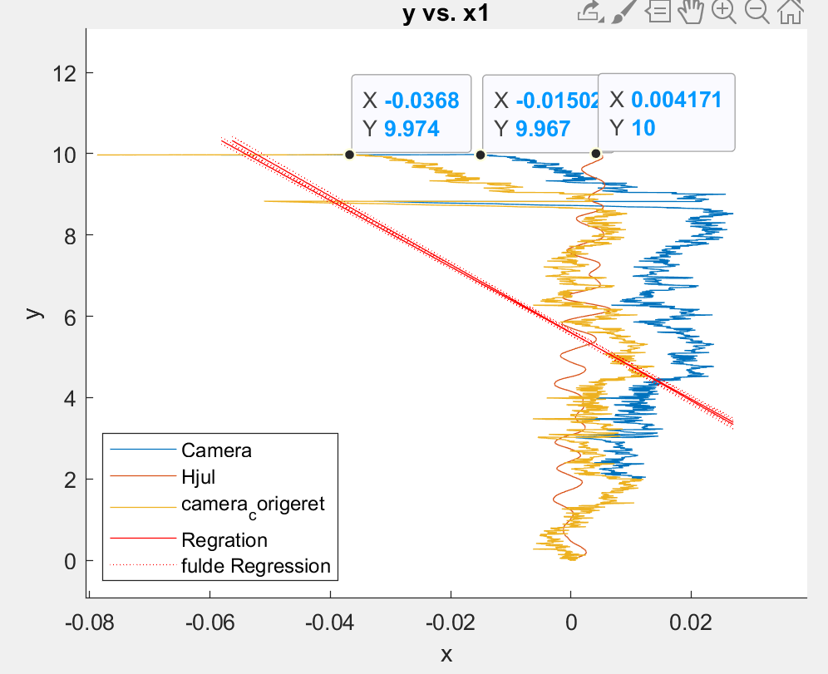 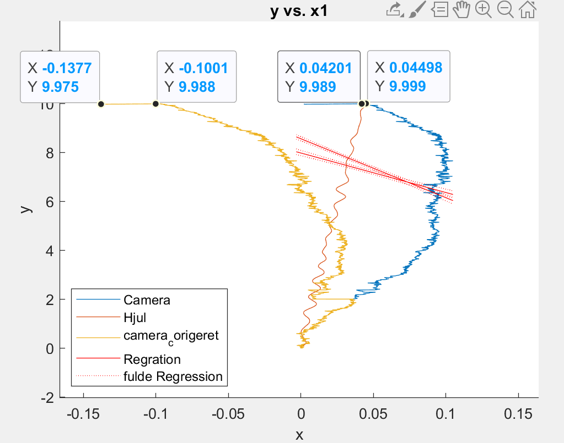

10

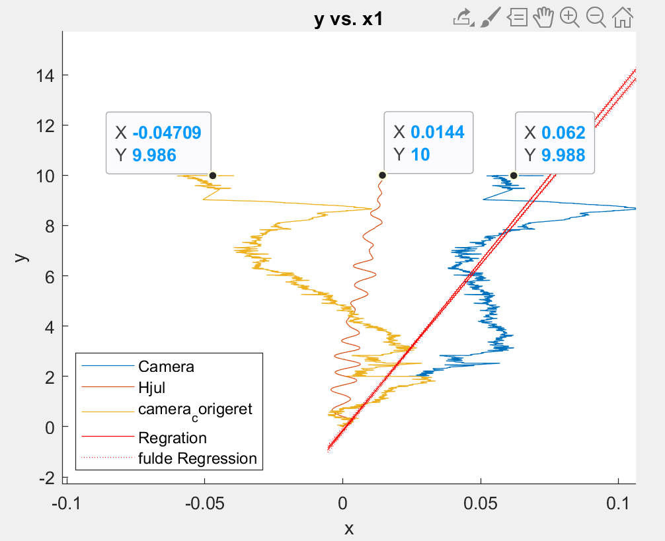

**Actual Deviation From 0**

1, 10m_Fast, 9.975, 14 cm right

2, 10m_Fast, 9.98, 19 cm to the right

3, 10m_Fast, 9.98, 2 cm to the right

4, 10m_Fast, 9.975, 7 cm to the Right

5, 10m_Fast, 9.98, 16 cm to the left

6, 10m_Fast, 9.975, 19 cm to the right

7, 10m_Fast, 9.98, 17.5 cm to the right

8, 10m_Fast, 9.98, 11 cm to the left

9, 10m_Fast, 9.98, 18 cm to the left

10, 10m_Fast, 9.985, 5 cm to the left